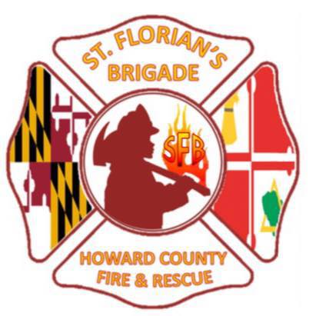
1st Alarm Fire Camp Application
Child's Name:
___________________________________________________________
Last First Middle
Date of Birth:____________________
Child's School: ______________________
Highest Grade Completed: _______
Home Address:____________________________________________________________________________ City: _____________________________ State: ________________ Zip:_____________________
Parent/ Guardian
Name:______________________________________________________
Home Phone: ___________________
Work Phone: ___________________
Cell Phone: _________________
Parent /Guardian
Name:______________________________________________________
Home Phone: __________________
Work Phone: ________________
Cell Phone:____________________
Parent/Guardian’s Email address (all communication about Fire Camp will be to this email address):
___________________________________________________________
DOES THE INDIVIDUAL HAVE A DISABILITY THAT REQUIRES ASSISTANCE?
YES (Please describe)
No
LIMITATIONS/RESTRICTIONS (ACTIVITY OR DIET) _______________________________________________________
___________________________________________________________
THIS INDIVIDUAL IS FREE OF INFECTIOUS DISEASE, IS UP TO DATE ON ALL IMMUNIZATIONS AND IS ABLE TO PARTICIPATE IN RECREATION ACTIVITIES ______YES ______NO

CIRCLE ONE - Child’s shirt size:
Youth: S (6-8) M(10-12) L(12-14) XL(14-16)
OR Adult: S M L XL

If you would like to make a donation, please send a check to St. Florian’s Brigade at 2201 Warwick Way, Marriottsville, MD 21104.

** Applications will be accepted on a first come first serve basis.
There is a preference for first timers and Howard County residents.
Limited to 45 spots. **

