
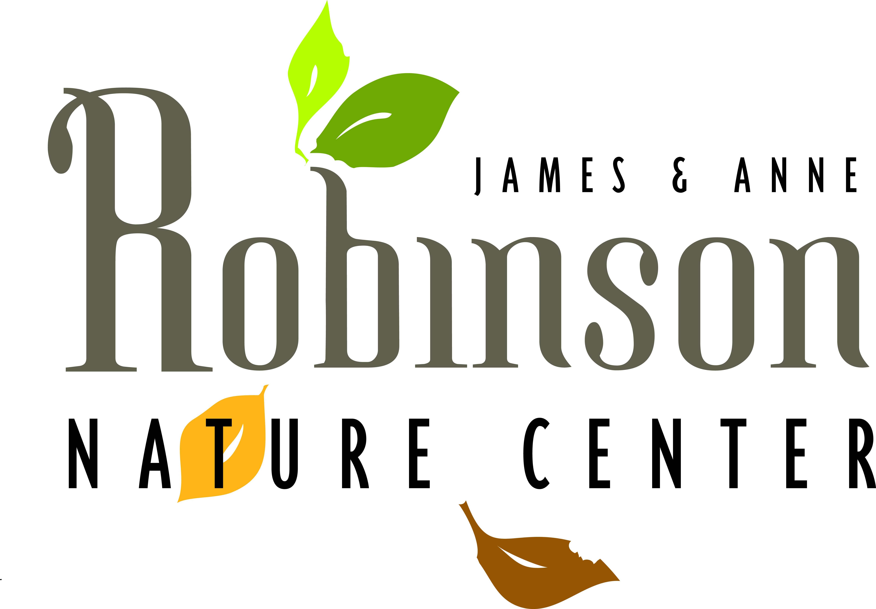

PARTICIPANT INFORMATION FORM
Robinson Nature Center Home School Program 2016-2017
You must fill out both sides of this form
General Information: (Please Print)
Participant Name: Participant Date of Birth:
Gender: Male Female Age: Grade:
Parent or Guardian Name: Parent/Guardian Date of Birth:
Address: City: Zip:
Home Phone: Work Phone:
Cell Phone: Email Address:

Individual(s) to be contacted in case of emergency:
Name: Relationship: Phone:
Name: Relationship: Phone:

Person (other than parent) authorized to drop off / pick up participant:
Name Relationship:
Home Phone: Cell Phone:
Are there any custody issues we should be aware of? No Yes (if yes, attach a copy of court order)

Health issues and special accommodations:
Are there any health concerns that our Staff should be aware of? (asthma, allergies, hypoglycemia, seizure disorder, etc.) No Yes (if yes, please specify)

What symptoms would your child exhibit?
Requested actions to be taken by staff:
Please indicate any of the following health problems or disability: (please check all that apply)
- Deaf / hard of hearing Vision impairment
- Seizures Uses mobility aids (i.e. wheelchair, braces, etc.)
- Development disability (i.e. autism, intellectual, etc.)
- Other (i.e. behavioral / emotional disorder, etc.)

Please explain any specific health issues or accommodations needed to participate in program:
- Inclusion Companion Deaf interpretive services
- Other (please specify)

PARTICIPANT CODE OF CONDUCT
The Robinson Nature Center is dedicated to providing exceptional programs to all participants. We want participation in our programs to be a great experience for everyone involved. To accomplish this goal, and nurture a positive learning environment, children are asked to abide by the Code of Conduct below.

Please review the Code of Conduct with your child prior to enrolling in a Robinson Nature Center program as these expectations will be enforced. . Please note that if you bring non-participating siblings, parents are responsible for these children at all times and must remove disruptive children from the classroom.

I agree to:
• Respect other participants, and treat them with kindness and courtesy. This includes being a good team player, taking turns and keeping my hands to myself. I understand that pushing, kicking, bullying or any type of fighting will not be tolerated.
• Respect Nature Center staff and teachers. This includes being a good listener and following directions.
• Respect the natural environment by not littering and not taking plants or animals out of their natural environment.
• Respect Nature Center property and the belongings of the other participants. I understand that throwing things is inappropriate and not allowed.
• Communicate in an appropriate manner. I will not yell, interrupt others while they are speaking or use foul language.
• Follow the outside safety rules. These include walking along the trails, staying behind my teacher and respecting nature.
• Remain under the supervision of my parent/guardian before and after class.
• Take responsibility for my actions.

Staff is committed to providing every child with meaningful, enjoyable learning experiences that enhance their appreciation of nature. If behavioral issues arise, staff will seek parental support and work towards encouraging positive behavior. Instances of inappropriate behavior will be documented and participants who remain disruptive may be dismissed from the program without refund. We thank you in advance for your support and cooperation.

In addition to the Participant Code of Conduct, I agree:
- To inform a staff member of any dangerous or potentially hazardous situation that I may observe.
- That if I do not understand how an activity is performed or how a piece of equipment is to be used, I will ask a staff member prior to beginning that activity.
- To inform a staff member if I have any problems meeting the physical requirements necessary for participation in any activities.

I am aware that while participating in a recreation activity or program arranged by the Howard County Department of Recreation and Parks, certain risks and dangers may be present, including but not limited to those generally associated with certain activities, the hazards of traveling the public highways, of accidents, of illness, and of those forces of nature.

I agree to indemnify and defend Howard County and hold it harmless from and against any and all claims, suits, damages, liabilities and expenses, including attorney’s fees and the County’s costs of defense, in connection with loss of life, personal or bodily injury and /or damage to or loss of property that arises from the participation of
(Name of Participant) in the Robinson Nature Center Home School Program, except to the extent that such loss or damage is occasioned by the negligent act or omission of the county, its officers, agents or employees and no negligence on the part of the Participant.

By signing below, I agree that I have read, understand and agree to the above information.
Signature of Participant  (if old enough to write) |  | Date:
Signature of Parent/Guardian: |  | Date:

For questions regarding Home School Classes or the Home School Workshop, contact Robinson Nature Center,
410-313-0400 or see www.howardcountymd.gov/RobinsonNatureCenter#HomeSchool

