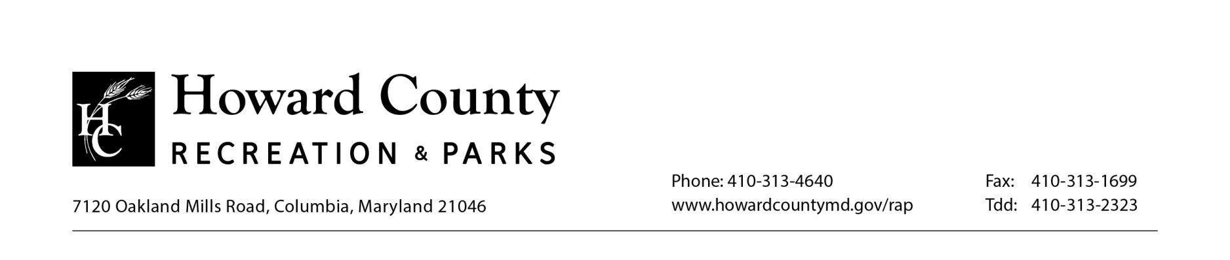
ADA Complaint Form for Patrons and Visitors
Person completeing form (check one):

Name: ______________________________________________
Address: ____________________________________________
____________________________________________
Telephone #: (___)____________________________________
E-Mail: ______________________________________________

ALLEGED VIOLATIONS
Describe the circumstances and specific location, i.e. park name /location, in which the alleged ADA violation occurred. Please be specific and provide details (attach additional pages if necessary).
________________________________________________________________________________________________________________________________________________________________________________________________________________________________________________________________________________________________________________________

REQUESTED ACTION
Please describe the action(s) you would like taken to correct the alleged ADA violation. Please be specific.
________________________________________________________________________________________________________________________________________________________________________________________________________________________________________________________________________________________________________________________

________________________________ ______________________
Signature Date

