Robinson Nature Center Spring Native Plant Sale
Vendor Invitation 2020

Event: Native Plant Palooza
Date: Sunday May 3, 2020
Time: Noon-4:00 PM
Vendor Set up: 10:30 AM- Noon

Hello,
On behalf of the Robinson Nature Center, we would like to invite you to sell your plants at our 7th Annual Native Plant Sale. The “Native Plant Palooza” will be held Sunday, May 3rd, 2020 between Noon and 4:00 PM. Set up for vendors will occur between 10:30 AM and Noon.

Robinson Nature Center is a LEED platinum certified nature center located on Cedar Lane in Columbia, Maryland just off Rt. 32 in Howard County. As part of our mission, we promote native plant gardening and native landscapes. Each year, our Native Plant sale draws hundreds of residents from across the county and surrounding counties.

Tips for Vendors:
- If you’d like to participate as a vendor at our native plant sale, please fill out the 2020 Vendor Registration Form and return it by April 15, 2020.
- Plan to bring a large variety of trees, shrubs, vines, ground covers and perennials. Common milkweed is an extremely popular request, and if you have it, we recommend bringing it.
- If you have the ability to process credit cards, we recommend you plan to bring your credit card processing device with you. We encourage patrons to bring cash as we do not have an ATM on-site. If patrons come without cash, they are limited to purchasing with their credit card.
- Robinson staff can provide tables (up to 4) and chairs for vendors. We will also provide canopies to protect you from rain and sun. Please feel free to bring any banners, educational or promotional materials, but please also bring a way to secure those items to your table/ in your space.
There is no fee to participate in this event. However, we ask that each vendor make either a monetary or material donation. We suggest a donation of 10% of the profit from the sale to support the Native Plant Sale event or a collection of plants for our ever-expanding native gardens. Thank you for your support!
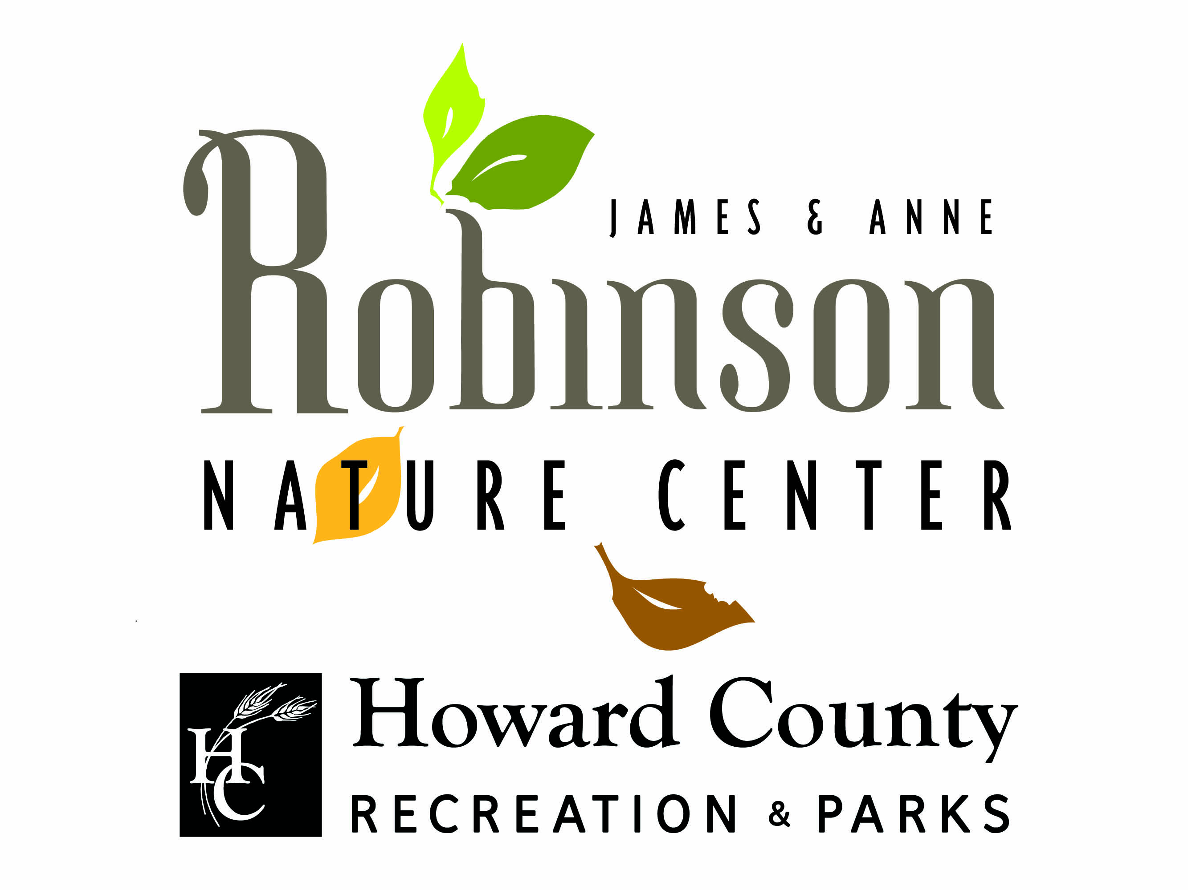
6692 Cedar Lane
Columbia, MD 21044
http://www.howardcountymd.gov/RobinsonNatureCenter
410-313-0400

