Renting GJACC A/V Equipment
$40 per rental*

MP3 Audio:
Includes: Multi room surround sound
Connections available: 3.5mm (audio), RCA (audio), Tape deck, CD player
MP3 Projector:
Includes: LCD Projector (120”), Multi room surround sound, Blu-Ray/DVD player, screen
Connections available: HDMI (audio & video), VGA (video), 3.5mm (audio), RCA (audio)
Portable Projector Cart:
Includes: LCD Projector, Bose Speakers, Blu-Ray/DVD player, built in screen or portable
Connections available: HDMI (audio & video), VGA (video only), USB (flash drive)
Portable TV Cart:
Includes: LED 46” TV, Xbox one Kinect with 2 controllers, Blu-Ray/DVD player
Connections available: HDMI (audio & video), VGA (video only), USB (flash drive)
Portable PA speakers:
Includes: Battery powered (6 hours) PA speaker with 2 wireless microphones, CD player
Connections available: CD (non-mp3), Mono audio

*Additional charges may be applied for damage or added us

We are a windows compatible facility; we do not provide any Apple unique cables or inputs. If you wish to use an i-device the only cable we provide is a 3.5mm Aux input cable. We suggest that you bring connection cables with you.

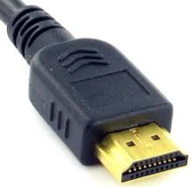
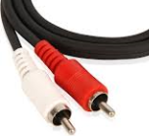
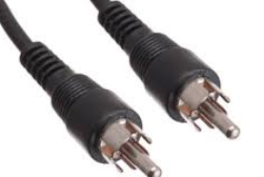
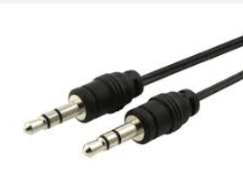
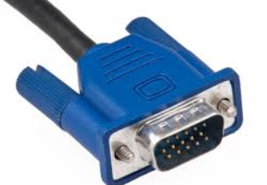
Aux or 3.5mm
VGA
HDMI
RCA
Mono RCA

