DTCS Project :

Deployed to: hwdiis2 server, hwdsql02 database server

TFS location:

DTCS Project (IT Purchase, Cell Phone Stipend) 4.0 app

$/DTCS/Source/DTCS

Database:

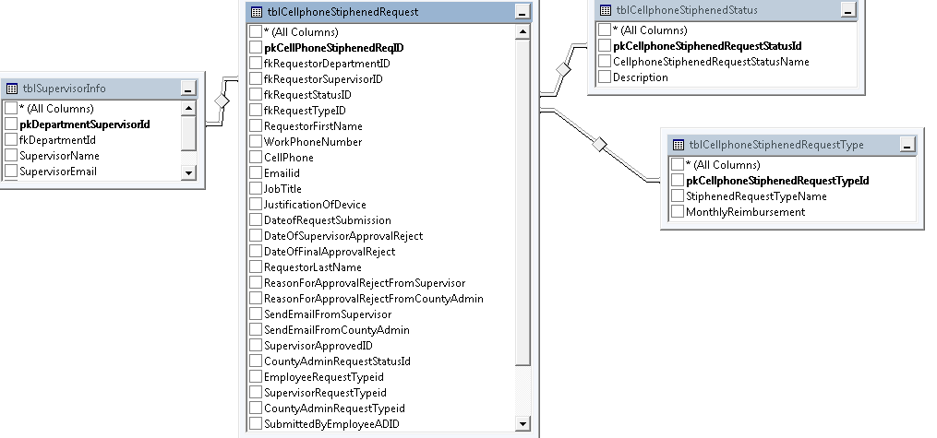

Cell Phone Stipend Request Type Table:

Request Type Name: Tier1, Tier2, Tier3, Tier4
Monthly Reimbursement: $90, $60, $30, $10

Cell Phone Stipend Status Table:

Status Name: Pending, Supervisor Approved, Supervisor Reject, CAO Approved, and CAO Reject.

(NOTE: Supervisor Modify, CAO Modify I am not using it)

Supervisor Information table:

Supervisor name, Email ID, windows id, employee id, Department id

(NOTE: This all information bringing from FMLA Database)

Bringing above data from Supervisor dropdown list selected index changed event (Stipend Requestor Form)

Store procedure: sp_getEmployeeInfo (This store procedure is in FMLA database)

Cell Phone Stipend Table:

Requestor Info:

Requestor Name, Email, Class Designation, Employee id

(NOTE: This all information bringing from FMLA Database)

Bringing above data from Employee dropdown list selected index changed event (Stipend Requestor Form)

Store procedure: sp_getEmployeeInfo (This store procedure is in FMLA database)

Department Info:

fkRequestorDepartmentID varchar(50) ( NOTE: department name bringing from FMLA)

Binding data of employee and supervisor dropdown list on department dropdown list selected index changed event (Stipend Requestor Form)

Store procedure: sp_bindEmployeeCombo (This store procedure is in FMLA database)

Request Status Info:

FkRequestatusid, SupervisorApprovedID, CountyAdminRequestStatusId

When requestor submit form that time status will be pending.
Whenever status get change that time FkRequestatusid will be overwrite.

(To keep archive data what was decision by supervisor, CAO
I am storing data in SupervisorApprovedID, CountyAdminRequestStatusId)

Request Type Info:

fkRequestTypeID ,EmployeeRequestTypeid, SupervisorRequestTypeid, CountyAdminRequestTypeid

Whenever request type get change that time fkRequestTypeID will be overwrite.

(To keep archive data what was decision by Employee, supervisor, CAO
I am storing data in EmployeeRequestTypeid, SupervisorRequestTypeid, CountyAdminRequestTypeid)

Employee Workflow

Requestor submits form = status will be pending

Supervisor can review form

If supervisor approve = status will be supervisor approved
If supervisor reject= status will be supervisor rejected

CAO can review form

If status= supervisor approved then

Only CAO can review
Else

CAO will not see if rejected by supervisor.

Deputy/Director workflow

isDirector flag will be 1 if requestor is deputy/director otherwise 0

If requestor is Deputy or Director submits form then status will be supervisor approved.

CAO can review form

