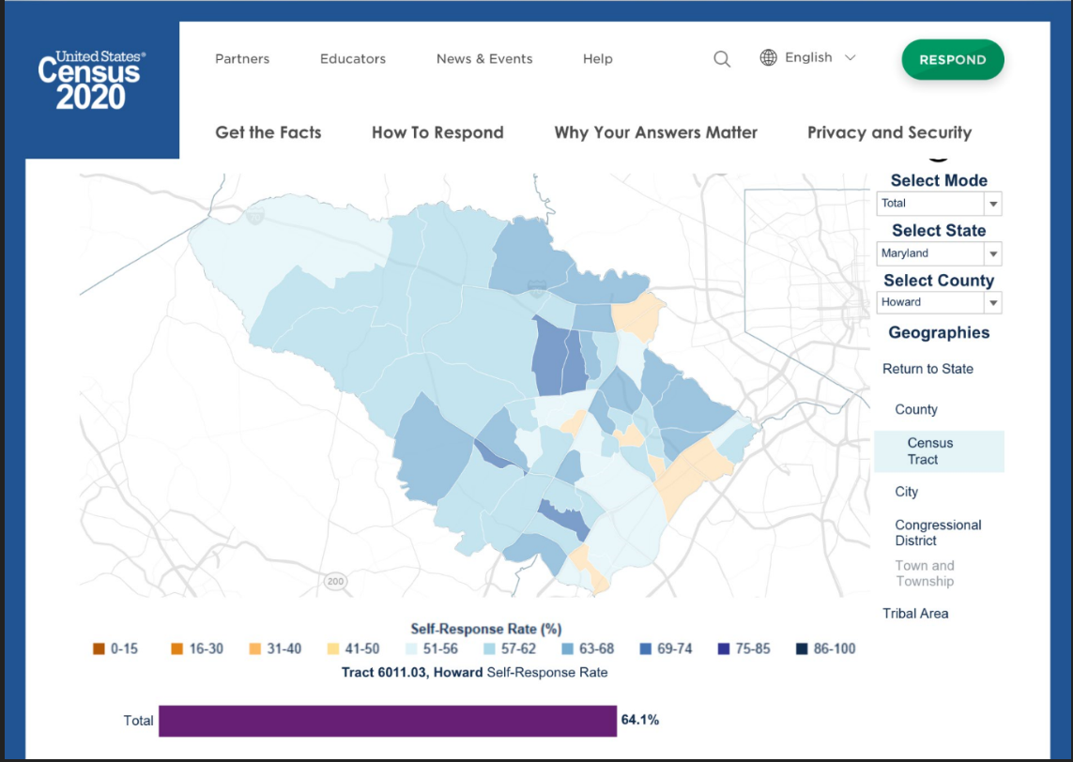
LAUREL
ELKRIDGE
COLUMBIA
COLUMBIA
COLUMBIA
ELLICOTT CITY
Census Response Rate Map

