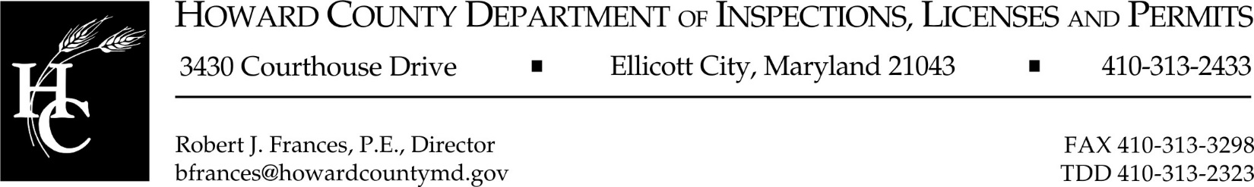

ELECTRICAL EXAMINERS MEETING MINUTES

JUNE 19, 2017

Attending:
Scott Harding
Syed Ahmad
Karen Greenfield
Eric Shatzer, teleconferenced in
Donald Mock
Jim Jackson
José Berríos Köhler
Elaine Hauck

Don Mock called the meeting to order at 5:30 pm

Order of business was to review the 2017 National Electrical Code being sent to the County Council for introduction, for an August prefile and estimating a December 2017 adoption.

SECTION 90.4 ENFORCEMENT
Add a sentence at the end of this section as follows: “If there is a conflict between this section and any other provision of this subtitle, the requirement of the other provision shall govern.”

ARTICLE 100. DEFINITION
Delete the sentence following: “Authority having jurisdiction (AHJ)” and subtitle the following, “The authority having jurisdiction is the Building Official as set forth in Section 3.101(A)(2) of this code.

SECTION 210.8 GROUND-FAULT CIRCUIT-INTERRUPTER PROTECTION FOR PERSONNEL
Subsection (A), Dwelling Units, add exception number 1 as follows:
Exception NO. 1: A single receptacle that supplies sump pumps and sewer ejector pumps is not required to have ground-fault circuit-interrupter protection provided that a GFCI receptacle is adjacent to the single receptacle.

SECTION 212.12 ARC-FAULT CIRCUIT-INTERRUPTER PROTECTION
Remove/eliminate Subsection A from our local amendments
Add Exception No. 2: Arc-Fault-Circuit-Interrupter protection is not required for newly installed 120 volt interconnected smoke detectors.

SECTION 230.71 MAXIMUM NUMBER OF DISCONNECTS
No Change

SECTION 240.21 LOCATION IN CIRCUIT
No Change

SECTION 250.52 GROUNDING ELECTRODES
All board members voted to eliminate this from the code

** An online vote started on June 22, 2017 and concluded on June 27, 2017. This amendment was placed back into the code.

SECTION 310.106 CONDUCTERS
No Change

SECTION 334.10 USES PERMITTED
Remove from code

SECTION 334.12 USES NOT PERMITTED
Remove from code

All members voted aye (4) to the above changes, 0 nays.

There was a brief discussion regarding subjects for possible future meetings.

Don Mock will provide all the board members with the new amendments that become effective July 1, 2017 to the Open Meetings Act, regarding open and closed meetings.

Don Mock will also confirm the number of electrical persons, engineer(s) and private citizens to make up the Board of Electrical Examiners.

Meeting adjourned at 5:53 pm

** This vote was held after the hearing, to make a change to the decision that was made to Section 250.52 Grounding Electrodes, during the meeting.

