Howard County Public Website - Content Management System (CMS) Training Manual
Version: 1, 12/16/15

Prepared by:
Planet Technologies, Inc. & Howard County DTCS

Table of Contents
Terms & Definitions 4
Introduction 5
Who Can Do What? 5
Department Content Editor 5
Department Content Managers 5
Site Admins 5
Where to go for Help 5
Logging In 6
Internet login 6
Content Managers and Content Editors 6
Site Administrators 7
Logout 7
Reset Password 7
Managing Content Pages 9
Add New Page 9
New Page Settings 10
New Page Workflow Recommendations 10
Page Details Tab 11
Advanced Settings 12
Edit Page 13
Edit the Text/HTML Module 14
Rich Text Editor Tools 17
Spell Check 17
Find and Replace 17
Paste 18
Undo/Redo 18
Insert Media 18
Hyperlink Manager 20
Accordion Tabs 22
FAQ Module 26
Links Module 29
File Management 31
Views 33
Actions 33
Selected Files 33
Action Buttons 34
Selected File Action Buttons 36
General Guidelines & Styling 38
Overview & Guidelines 38
User Guidelines from PIO 38
Fonts and Colors 38
Page Layout 39
Basic HTML Guide 40
Formatting Tags 40
Lists 40
HTML Tables 41
Accessibility Guidelines & Considerations (Section 508) 42
Overview 42
Best Practices 42
Page Layout 42
Navigation – External Links 42
Images 43
Tables 43
For More Information 43
Managing News 44
Overview 44
Viewing News Articles 44
Accessing the News Module 45
Adding a News Article 47
Editing an Existing News Article 52
Managing Calendar 53
Overview 53
Adding a Calendar Item 53
Accessing the Calendar Admin 53
Adding the Event 54
Editing an Existing Calendar Item 57
Event Images 58
Appendix 59
Examples: 59
Event Page (Single page using Text Editor and Accordion Module) 59
Anchor tabs vs. Accordion Menu 61

Terms & Definitions
Term | Definition
HTML Attribute | Part of an HTML tag that either describes the tag or modifies the behavior of that tag
CMS | Content Management System. A type of website which allows users to manage content on a website, without having access to the underlying structure of the site such as HMTL and graphics.
Content | Content is a term used to refer to the text, images, and hyperlinks that make up the informational areas of the web page. Content does not include items such as navigation, search boxes, and other structural features of the website.
Content Editor | Content Editor is a user role within DNN. This role allows you to add & modify content for approval by a Content Manager. Content Editors do not have the ability to publish content live to the site.
Content Manager | Content Manager is a user role within DNN. This role allows you to add & modify content. The role also allows you to approve content that has been submitted by a Content Editor. Content Managers have the ability to automatically publish adds/modifications to the live website.
DNN | Dot Net Nuke. The technology platform used for the Howard County Internet
HTML | HyperText Markup Language; the set of tags used to build web pages.
Hyperlink | A link from a hypertext file or document to another location or file, typically activated by clicking on a highlighted word or image on the screen. Hyperlink, Link, and URL have the same basic definition.
Link | A link from a hypertext file or document to another location or file, typically activated by clicking on a highlighted word or image on the screen. Hyperlink, Link, and URL have the same basic definition.
PDF | Portable Document Format. A format for a computer document file that enables a document to be processed and printed on any computer using any printer or word-processing program. PDFs are generally used in the internet/web world instead of formats such as Microsoft Word which are editable and require the Citizen to own a copy of the program in order to open the file.
Section 508 | An amendment to the Federal Rehabilitation Act that requires government websites to be accessible to all users regardless of disability.
HTML Tag | The basic component of HTML, words or abbreviations enclosed in angle brackets, e.g. “<HTML>.”
URL | Uniform Resource Locator. A link from a hypertext file or document to another location or file, typically activated by clicking on a highlighted word or image on the screen. Hyperlink, Link, and URL have the same basic definition.

Introduction
Welcome to the Howard County public website content management system. The purpose of this document is to provide the department content managers and editors with a manual for quick reference when adding and managing content on the Howard County Government website.
If you are just learning a task or returning to a task you have not done in a while, you may wish to read the relevant section from this document first and then follow the on-screen prompts to complete the task. If you are more familiar with a task, you may only need this document to refresh your memory for parts of the task.

Who Can Do What?
All network users may view published pages on the Internet site.
Each department has a Content Editor and a Content Manager that can edit and manage the content and pages for their department ONLY.

Department Content Editor
- Add new page but NOT modify page permissions.
- Add, modify, or delete an existing module to a page.
- Add, modify, or delete content on a page.
- Upload a file, view and edit file properties (e.g. rename), or get the file's URL.
- Save pages.

Department Content Managers
- All tasks listed above for Department Content Editors plus:
  - Modify page permissions
  - Delete files
  - Publish pages

Site Admins
- All tasks listed above for Department Content Managers plus:
  - Rearrange pages in the menu
  - Modify the Home Page
  - Add new users and modify user permission (when authorized to do so).

Where to go for Help
For technical problems regarding the Howard County Internet Training Manual, please contact HoCoUsers@howardcountymd.gov

HoCoUsers Hours  7:00 AM-5:00 PM  Monday – Friday | Phone  N/A

Logging In

Internet login
Browse to http://www.howardcountymd.gov/login.aspx to access the Howard County Internet website. Users do not need to log in to view content. Site Admins, Content Managers and Content Editors must login to add, remove, or modify content.
- Enter your Username
- Enter your password
- Click Login
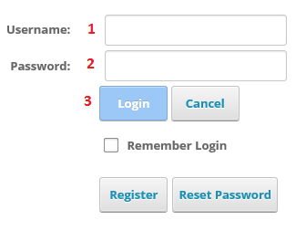

Content Managers and Content Editors
Content Managers and Editors may only edit their department’s content ONLY. When you navigate to any page in your department, the Dot Net Nuke (DNN) toolbar will appear at the top of the page. Detailed instructions on using the DNN toolbar are in following sections of this manual.
- Use the DNN Toolbar to add a page
- Click Edit Page to edit the current page
- Click Editors to upload and manage uploaded files

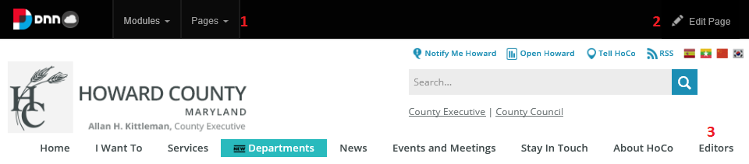

Site Administrators
Site Administrators will see the DNN Toolbar as soon as they log in.
- DNN Toolbar
- Edit Page
- File Management
- Skin Plugins

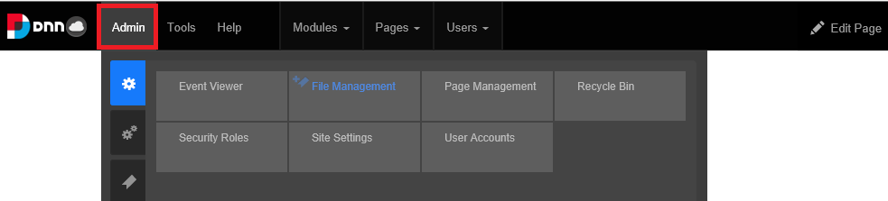

Logout
There is NO logout button or screen. To force a logout, you must close all open browser windows. Logged in sessions will automatically logout after approximately 10 minutes of idle time. Click F5 to refresh your screen to return to the login screen.

Reset Password
If you forget your password, go to the login page and click Reset Password.
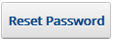
If you forgot your password, you can have an email with a password reset sent to your registered address. To do this enter your User Name and click Send Reset Link button.
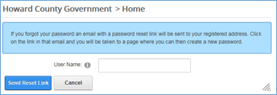
A confirmation screen will load. You may click the close window button (not shown) or click the Cancel button.
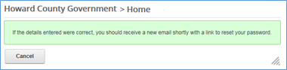
Check your email inbox for the password reset message. Verify the sender, the recipient, and your username. Once you have confirmed these you can either click the link in the email or paste the link into your browser’s address bar.

NOTE: If you did not request a password reset, DO NOT CLICK THE LINK, and DO NOT PASTE THE LINK into your browser. Unsolicited password reset requests are a major source of “phishing” attacks used by hackers to compromise your user account. Only click links that you can confirm are valid.

The Password Reset page will open. Confirm that you are on the right site, enter your username, type your new password and then confirm the new password. Click the Change Password button to complete the process or Cancel to not complete the process.
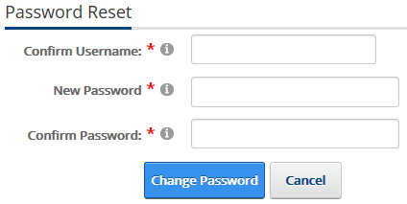

If your new password is not accepted the message to below will appear. Passwords must be a minimum of 8 characters and should be complex enough that no one can guess what it is. You may not re-use a previous password. Double check your username and try again. Return to the login screen to login once you have successfully reset your password.
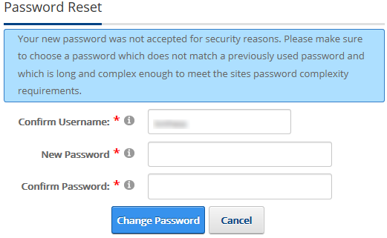

Managing Content Pages
Several options available to you in the Add New Page and Edit Page screens should not be modified. Many of these options were pointed out during training sessions. It is considered best practice to only use the options outlined within this manual. If you have questions regarding the functionality of other options, please contact HoCoUsers@howardcountymd.gov before attempting to use other functionality not covered in this manual.

Add New Page
The following steps will show how to add a page to the Internet site.
- Navigate to your department's landing page and note the appearance of the DNN toolbar.
- If needed, navigate to the desired "parent page" for your new page. Check the breadcrumbs to be sure you are on the correct page.
- Click Pages on the DNN toolbar and select Add New Page.
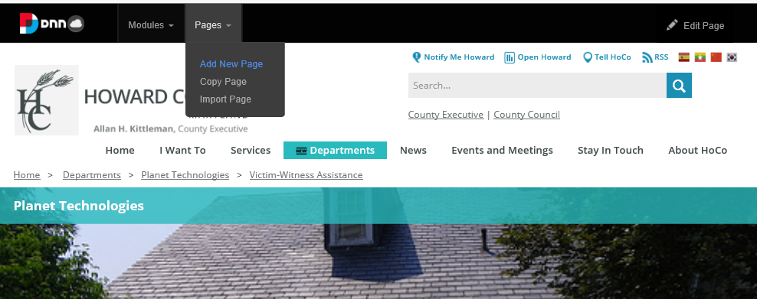

New Page Settings
- The Page Settings form appears on the screen. There are 4 tabs on the form: Page Details, Permissions, and Advanced Settings; these are covered in greater detail below.
- Copy Page is an advanced feature that will not be covered in this manual.
- The Permissions tab is visible to department content managers ONLY; content editors do not see the Permissions tab.
- You should review each tab before hitting the Add Page button. Permissions and Advanced Settings are available after the page is created.
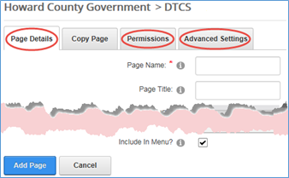

New Page Workflow Recommendations
Workflows are not yet in place but will be added in the near future, they are:
- Full Review
- PIO Only Review
- Department Only Review
This section of the Training Manual will be updated to reflect these workflows upon implementation.

Page Details Tab
Setting | Information
Page Name | REQUIRED The Page name is displayed in both the left menu and the default URL.  NOTE: Use of special characters and spaces will be encoded in the URL (but not the text displayed in the menu), e.g. a space will become %20 | 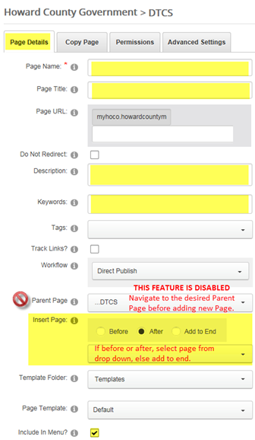
Page Title | The page title displays in the browser's tab. It may be left blank.
Page URL | Leave blank and the system will generate a URL from the Page name.  NOTE: Use of special characters and spaces will be encoded in the URL, e.g. a space will become %20
Description | Enter a description about this page here. The description will not be visible to all users, use to specified date updated and by whom for future reference.
Keywords | Enter some keywords for this page (separated by commas).
Tags | Select relevant tags from the list of available tags.
Workflow | Workflow affects the buttons that appear in edit page mode.  - Direct Publish: This option directly publishes the page and is visible to those who have view permissions for the page.  - Save Draft: Use this option to allow save before publishing. Saved drafts are NOT visible to users but are available to Editors, Managers, and Admins.
Parent Page | This feature is disabled for Content Managers and Editors.  NOTE: the parent page defaults to the current page when a new page is added.
Insert Page | Visible only if more than one page exists under the parent page. Select the page that you would like this page to be inserted before or after, or optionally add the page to end of the current level. A dropdown of exiting pages will appear when before or after radio buttons are selected.
Include in Menu? | You have the choice to include the page in the main navigation menu or not. If a page is not included in the menu, you need to know the page URL to visit or edit the page. NOTE: the page would be visible to anyone who knew (or stumbled on) the page URL. See next page for how Department Content Managers can modify the permissions to easily stage content before it is released to the general users.

Page ordering can be changed by a Site Admin. You do NOT have to delete and recreate your page. If you create a page in an undesired location, submit a ticket detailing the page name, where it currently resides, and where you would like it to be moved. Be careful to check the current page when creating future pages to ensure you are at the desired parent page.

Advanced Settings
Setting | Information
Disabled | Click the Disabled check box in the Appearance section if you want to hide the page indefinitely. | 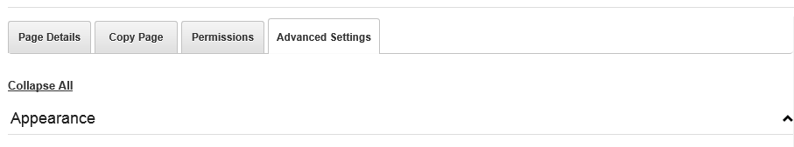    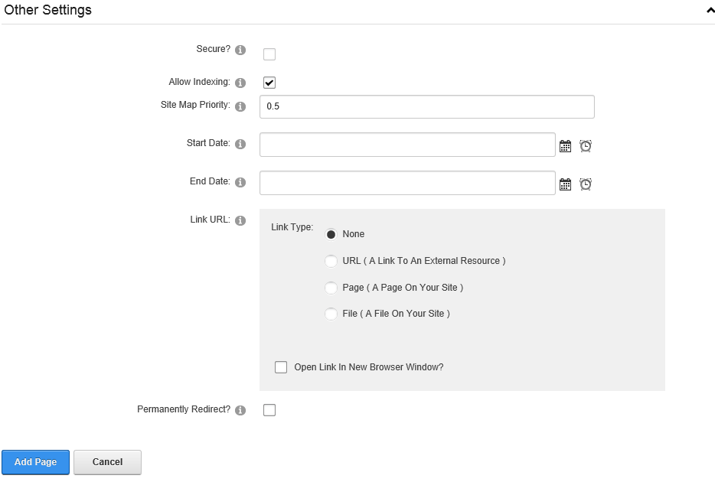
Start Date | Enter a start date if you do not want the page to appear on the site as soon as it is published, but want it to automatically appear at a pre-determined date and time.
End Date | Enter an End Date if you want the page to no longer be displayed after a pre-determined date and time.

Edit Page
Your page is created and ready to be edited. This section will get you familiar with the page layout and walk through the Text/HTML module. There are additional modules available which are not included in this manual. How to Guides for the advanced module will be available.
Click Edit Page on the DNN toolbar and then click Edit This Page to switch from View mode to Edit mode.
NOTE: if you selected the Save Draft workflow, your page will be blank until you are in edit mode.

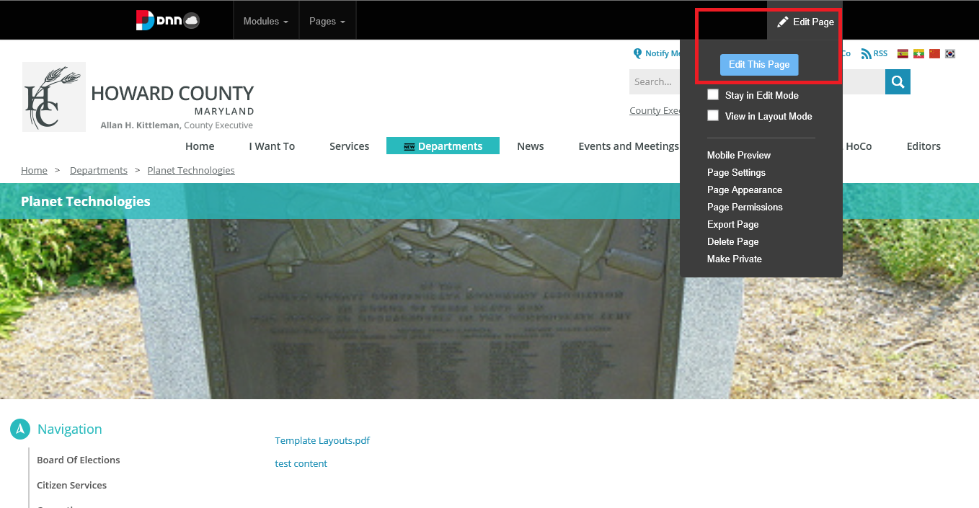
From the Edit Page dropdown, you may also opt to view/modify Page Settings or Page Appearance (Advanced Settings) and Managers may view/modify Page Permissions or Delete the Page.

CAUTION: DO NOT USE the Make Private option as this will render the page visible to Site Admins only. If you hit the option by mistake, you will be prompted to cancel. If you proceed, you will need to submit a service ticket to make your page public again. Use the Permissions Tab to make the page invisible to "All Users" while making it easily editable by content managers and editors.
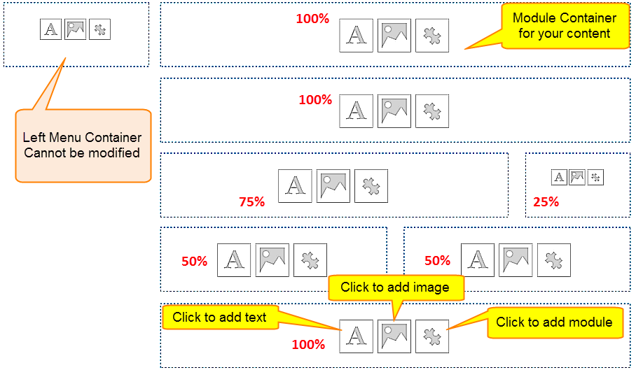

Edit the Text/HTML Module
Change the Module Title. Click either gear. From the top gear, select Settings from the dropdown.
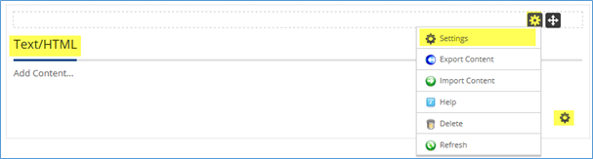
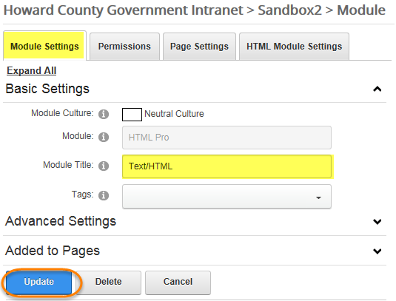
Type in the New Module Title and click Update.
Note: Removing the Module Title as described on this page may leave a block of whitespace on the page where the Module Title would have been.

Remove the Module Title
To completely remove the Module Title from the page, click on the Gear icon, then Settings.
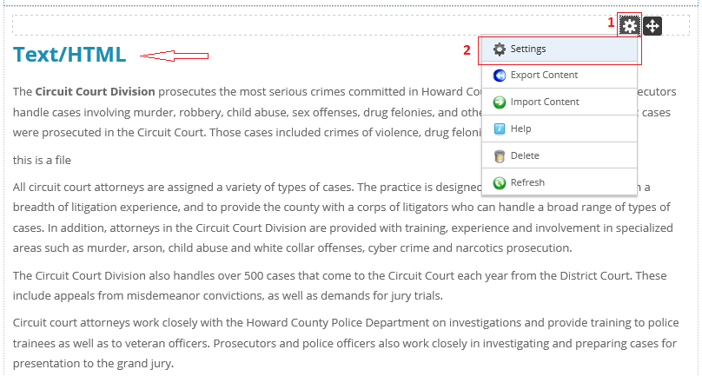
On the Module Settings pop-up, click on the Page Settings tab.
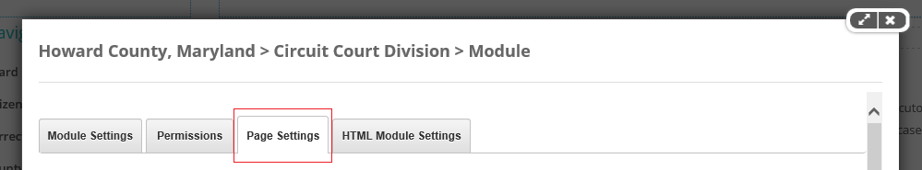
Scroll down and change the Module Container option to “No Title” as shown below. Click the Update button.
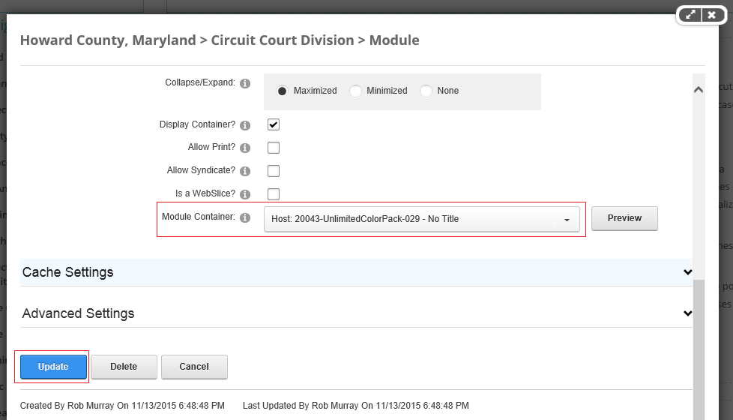

Basic Module Settings
Setting | Information
Module Culture: | The culture for this module. Accept the default "Neutral Culture"
Module: | Displays the name of the module. This CANNOT be changed.
Module Title: | Enter a title for the Module. This will appear in the Title Bar of the Container for this Module, if supported by the Container.
Tags: | Select items from the drop-down to tag this Module.

Text Editor
Place your cursor on Add Content… to open the Basic Text Editor.  NOTE: It is best practice to paste / enter text into the Basic Text Editor first, and only open the Rich Text Editor (below) if you need the extra functionality provided by the Rich Text Editor. | 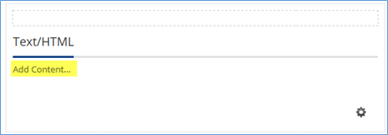
In the Basic Text Editor, click the icon to open the Rich Text Editor | 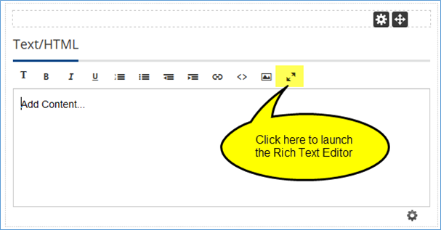

Rich Text Editor Tools
This section includes a description of the Rich Text Editor tools that are relevant to you.
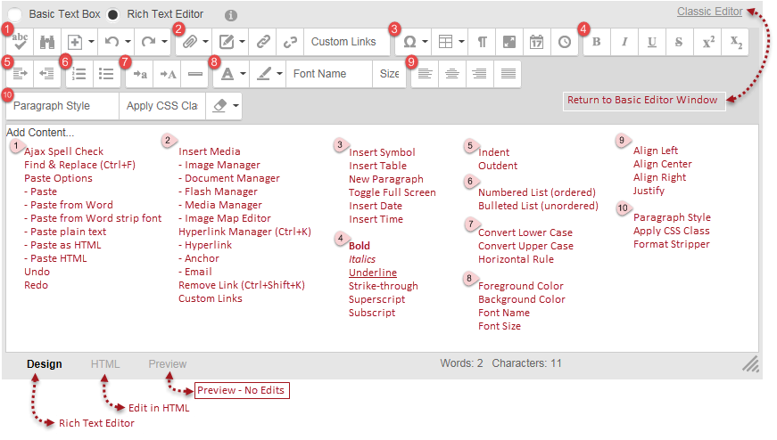

Spell Check
Use spell check to check for spelling errors. You may ignore an error, change it manually, or add the un-recognized word to the dictionary.
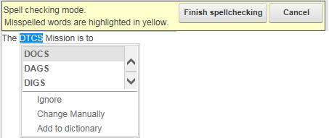

Find and Replace
Find
Finds text within the current module.
Replace
Finds and Replaces text within the current module.
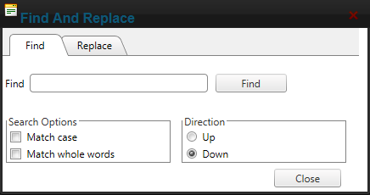

Paste
Paste is available from the Paste button dropdown or by right-clicking in the Rich Text editor window. The following paste options are available:
- Paste
- Paste from Word
- Paste from Word, strip font
- Paste Plain Text (Recommended)
- Paste as HTML
- Paste HTML
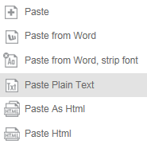

Undo/Redo
- Undo (CTRL+Z) will undo your last change.
- Redo (CTRL+Y) will redo your last undo.

Insert Media
Though there are 5 options presented on the Insert Media button, we are only concerned with the first two, the Image Manager and the Document Manager.
NOTE: At no time should you include any Flash content on your web pages. Please submit a support ticket if you feel you need Flash on a page in your department.

Image Manager
- Navigate to the folder in which your image resides, click to select.
- The selected image will be presented tin the Image Editor window.
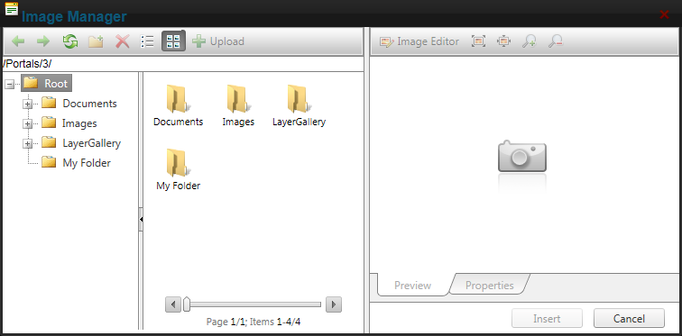

Document Manager
- Navigate to the folder in which your document resides.
- The document properties will be displayed in the third panel.
- Click insert to insert the document media.
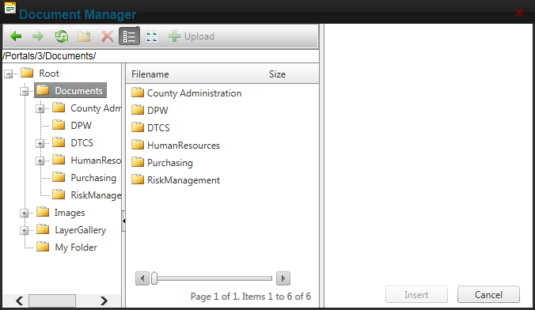

Hyperlink Manager

Hyperlink Tab
- Page
Use the page drop down to create a hyperlink to a page that exists on the Internet. Scroll to the desired page and click to select.
- URL
Use the Document Manager icon to create a hyperlink to a file that exists in the Internet File Manager. For an external hyperlink, type or copy the URL.
- Link Text
What the user sees/clicks on the screen.
- Target
Use New Window for documents and external hyperlinks. This opens a new tab or browser window.
Use NONE for hyperlinks that jump to other pages on the Internet. This opens the link in the same browser tab or window.
- Track
Check to track the number of times this link is clicked. Do NOT check log user, date, and time.
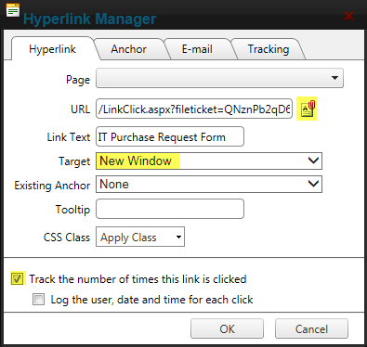
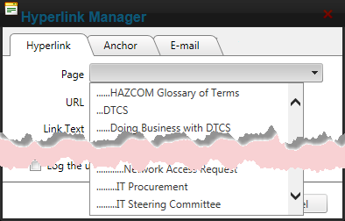

Email Tab
Address
Input the entire email address.
Link Text
What the user sees and clicks on. Recommend using the recipient's name or full email address.
Subject
Optional value. If used, the subject in the email message is automatically populated. 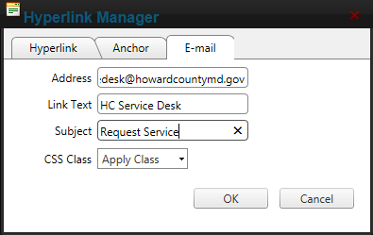

Accordion Tabs
The Accordion Tab allows you to combine multiple sections of content into a single easy to navigate module on your page. Accordions can have one or more tabs. Each tab contains a text area. When the tab is clicked, that will open or close thus revealing or hiding the content within the tab. Arrows along the right side of the module show whether the tab is opened (upward pointing) or closed (downward pointing). The image below provides an example of what an Accordion Menu looks like.
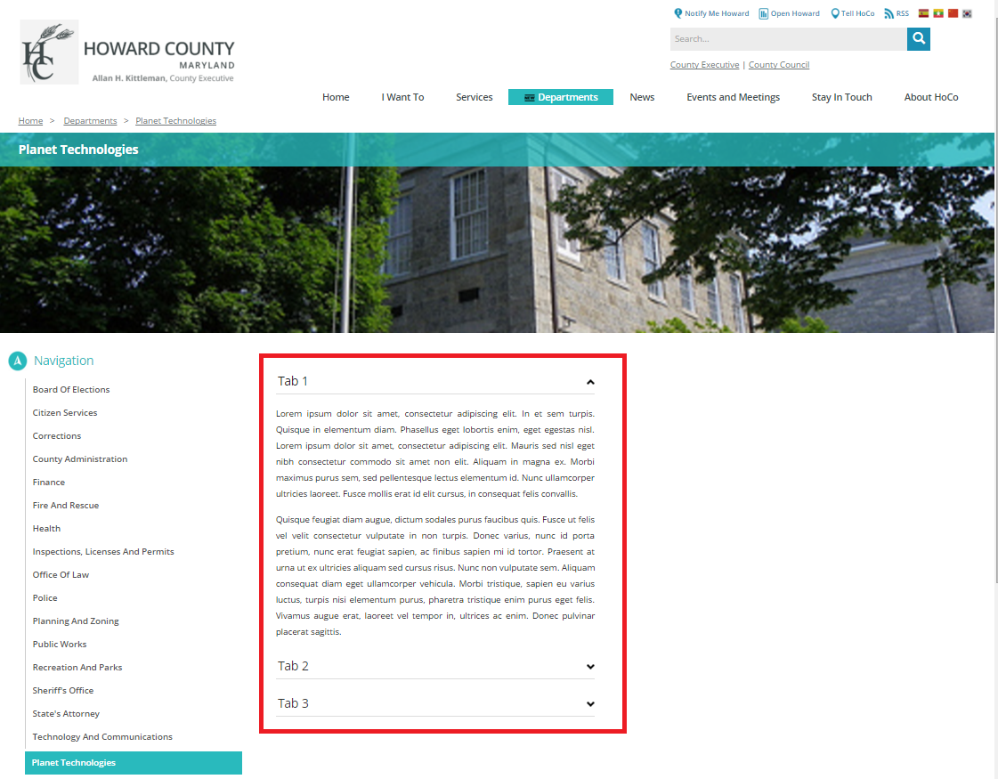
To add an Accordion Menu to your web page, navigate to the page, enter the Edit mode, and click on the Module icon in the Zone where you would like to place the Accordion Menu.
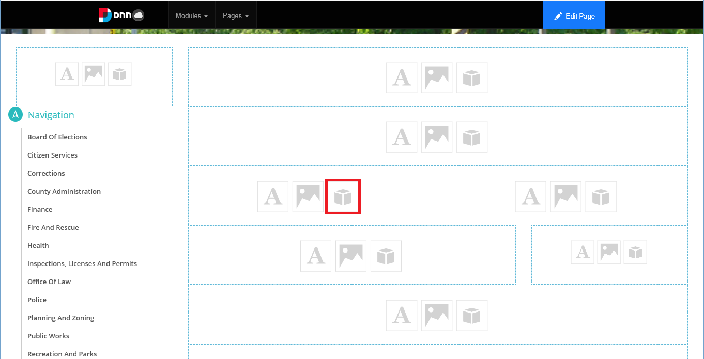
From the Add Module window, choose the Accordion Tabs module.
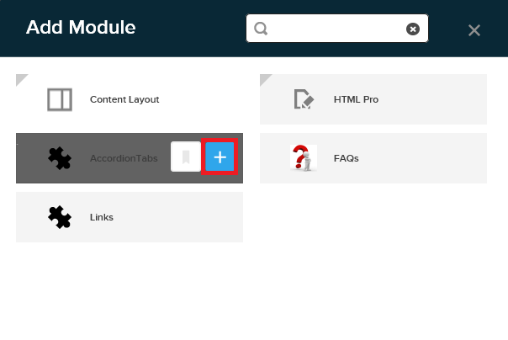
The module is added to your web page. To configure the module, hover over the pencil icon and click Manage Tab.
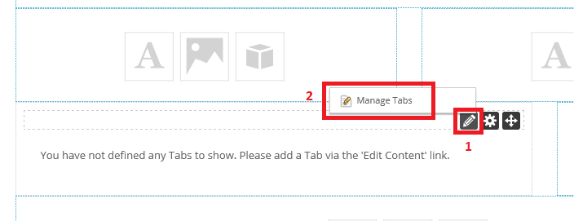
Each Tab will need to be added individually. Provide a Title for New Tab, then fill in and format the content for that tab.
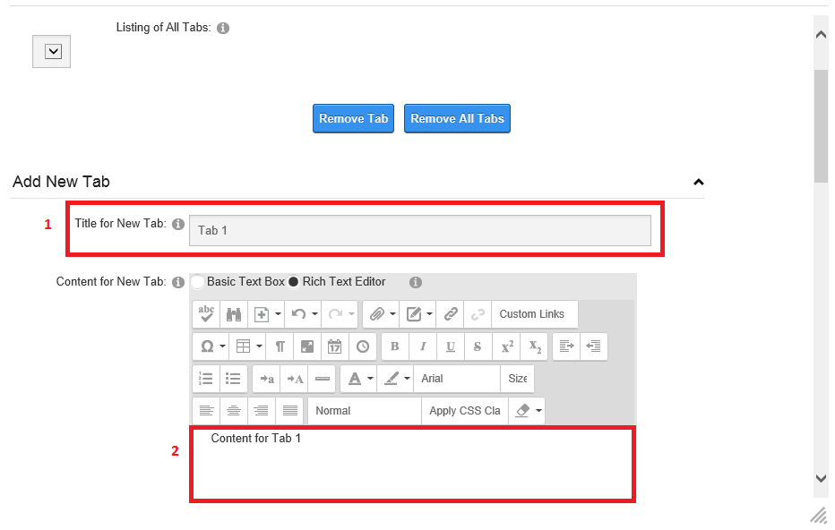
If you scroll down on the same window, you’ll have more options available, including whether you want the contents of the tab visible by default. When you’re done configuring the Tab, click Add Tab.
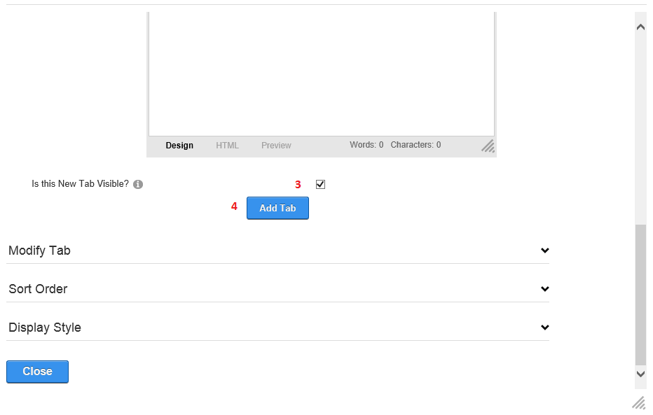
The new Tab will be created and added to the Listing of All Tabs, which is located at the top of the same screen.
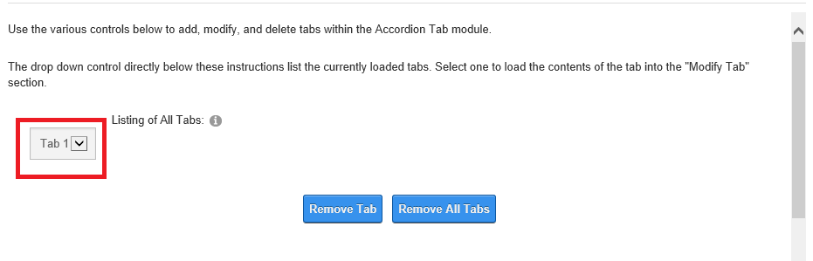
Continue adding the rest of the Tabs, content, and formatting as shown above. As you add more tabs, the List of All Tabs will begin to look like the following image.
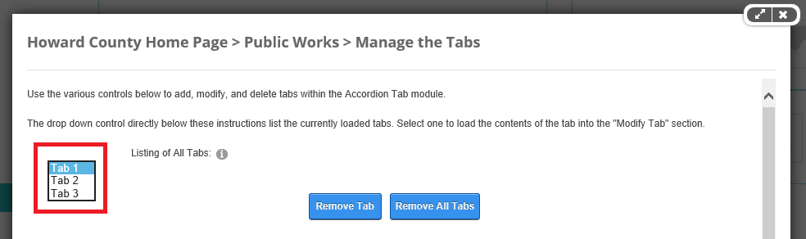

FAQ Module
Add the FAQ Module to the page using the steps described above. You’ll see the FAQs module with options of:
- Add New FAQ
- Manage Categories
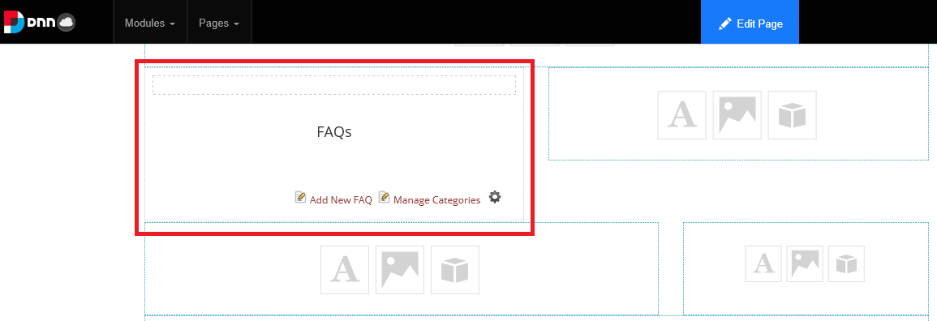
Click the Add New FAQ link. The “Edit this FAQ entry” screen will appear. You must fill out, at a minimum:
- Question
- Answer
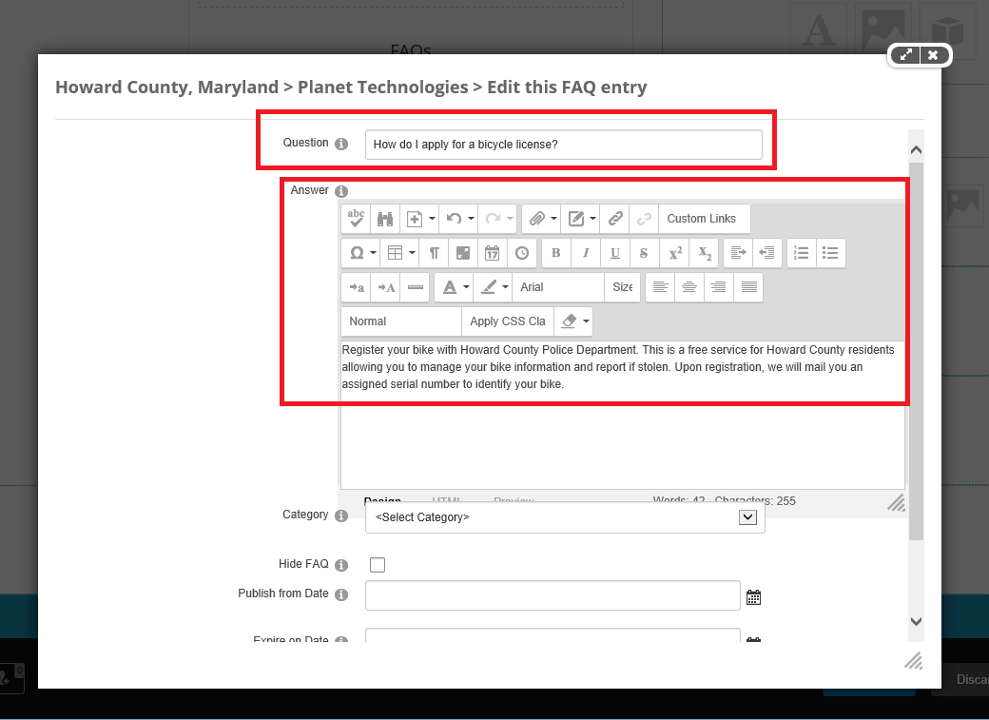
Remember that the Answer may contain HTML markup, such as images and hyperlinks. You can also associate the FAQ with a Category, or Hide FAQ (a good example would be seasonal FAQs such as snow-related queries), as shown above. If you continue to scroll down, you can also set the Publish from Date and Expire on Date. When done, click the Update button.
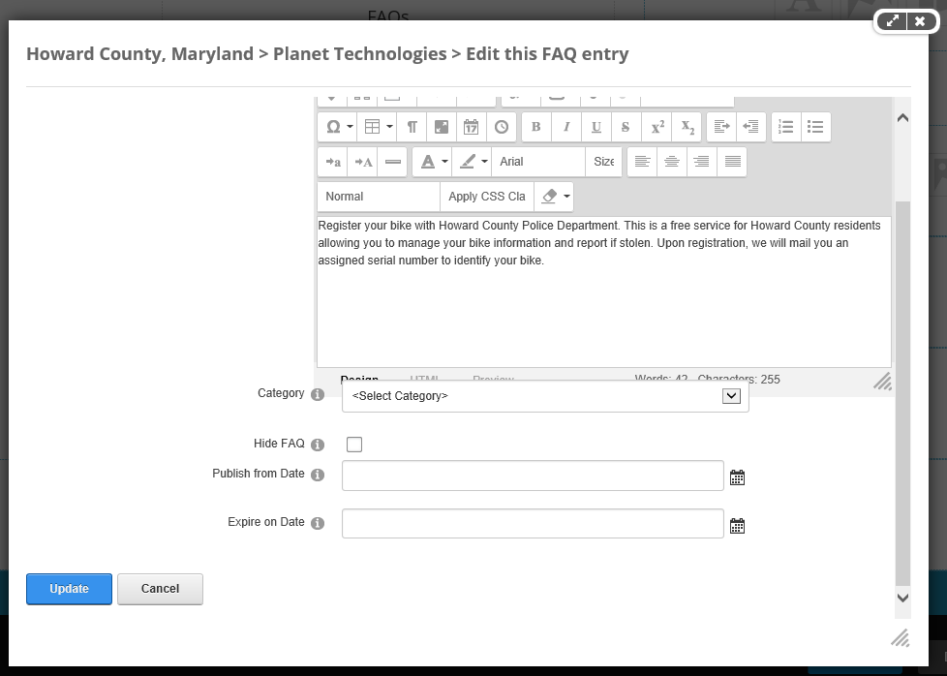

FAQ Categories
As referenced above, you may also want to create Categories for the FAQs. To create a Category, click on Manage Categories. The Manage Categories screen will appear.
- Click Add New
- Provide the Parent Category (if applicable), Category Name, and Category Description
- Click Update
Repeat these steps for each new Category.
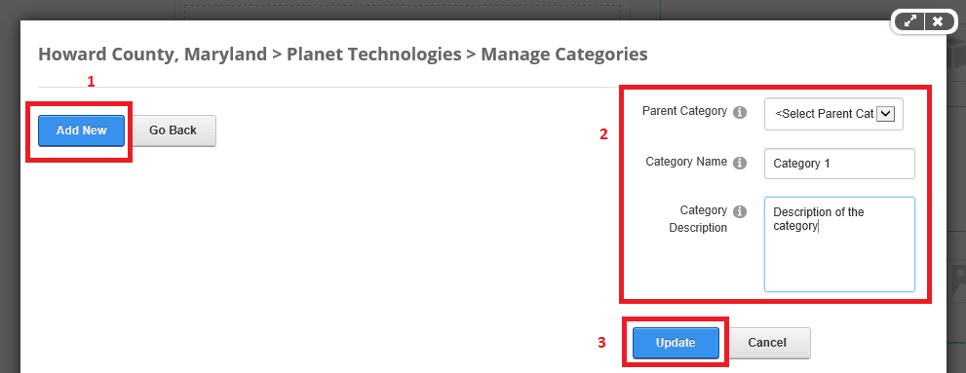
When done, Publish your changes. The FAQ module will look similar to the image below. FAQs will display, stacked in a column, with the Answer collapsed. You’ll be able to click on a Question to expand the Answer. Each time that the FAQ is expanded, the “Viewed” counter will increment by 1.
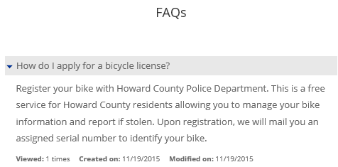

Links Module

Adding the Module
To add a Links module, follow the instruction for Accordion Module above, but choose a Links Module instead.

Configuring the Links Module
When the Links Module has been added, follow these steps to format the module and add content.
- To format the module, click the gear icon (below) and select “Settings” from the menu.
- To simply add links without performing any additional formatting, click the Add Link.
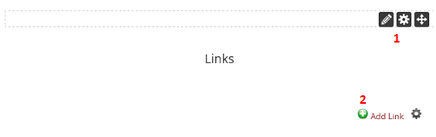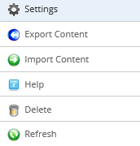
In the settings window for the Links Module:
- Click the Link Settings Tab  - Change the List Display Format between Vertical (default) and Horizontal.  - Determine whether or not the links will wrap or continue to the right  - Click Update when finished to apply the settings | 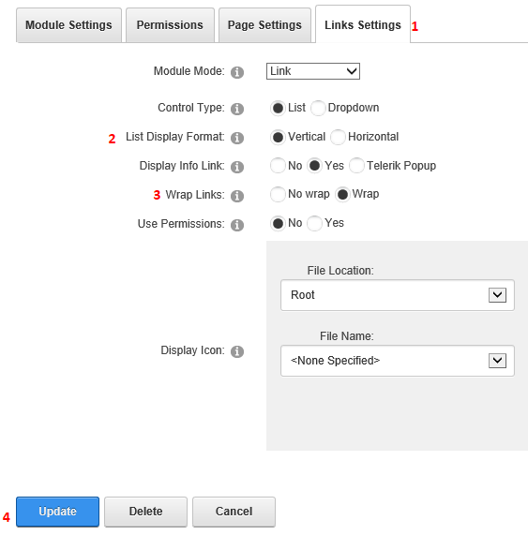

It is not recommended to alter any of the other Links Module settings.

To add links to the Links Module, click Add Link () and the page will load the form for entering a new link:
- Enter the title; this is what the user will click on.  - Choose from the first 3 link types.  - Location will change depending on the Link Type (2) you choose.  - You can choose to track the # of times a link is clicked and whether the link opens in a new window (recommended for external URLs), but DO NOT log the User/Date/or time.  - DO NOT select any roles.  - Enter a description for the link. This will be visible on the web page when the user clicks an ellipses (…) next to the link title.  - Set the view order for this link in relation to any other links that are already in the module.  - Click Update to save your changes or cancel to not save your changed and return to the page Edit view. | 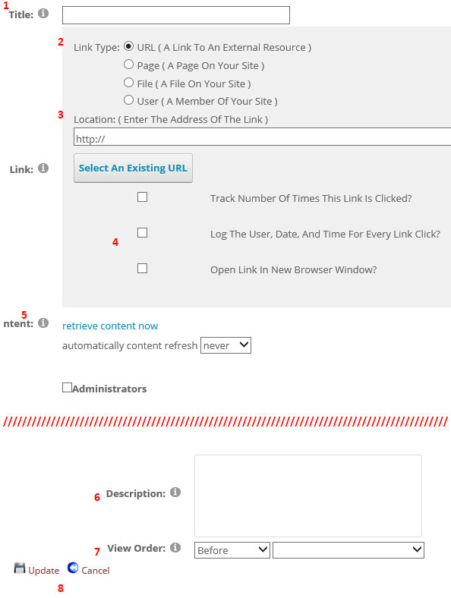

A basic list of links might look like this:

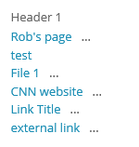

File Management
Log in to the site with your credentials and then click the “Editors” option (see image below) that appears to the far right of the top navigation for the site.
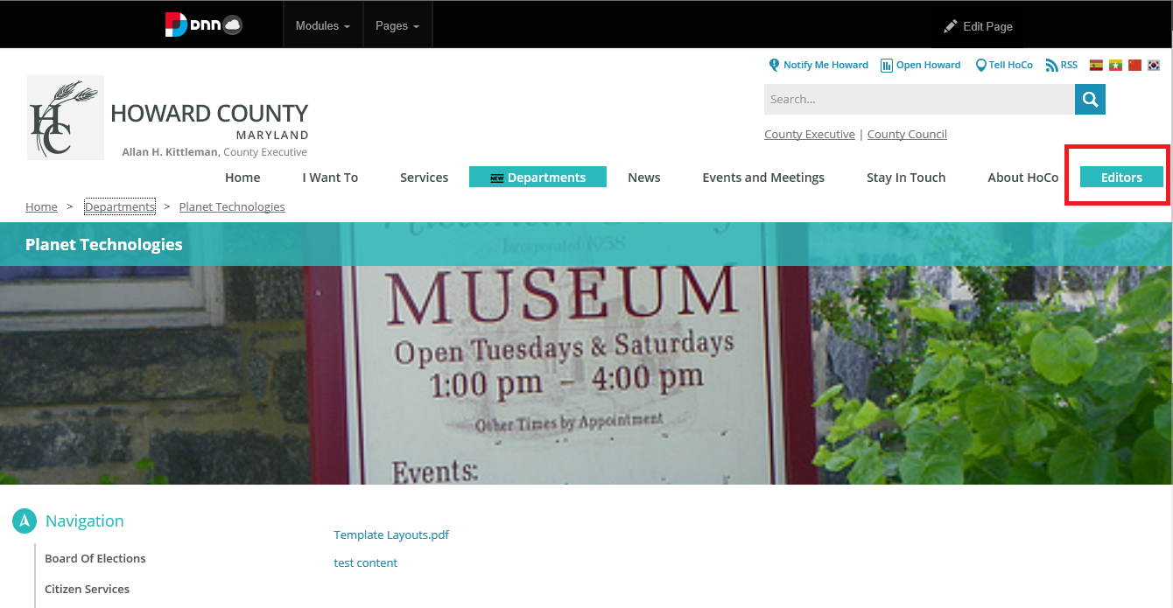
The File Management screen will appear.
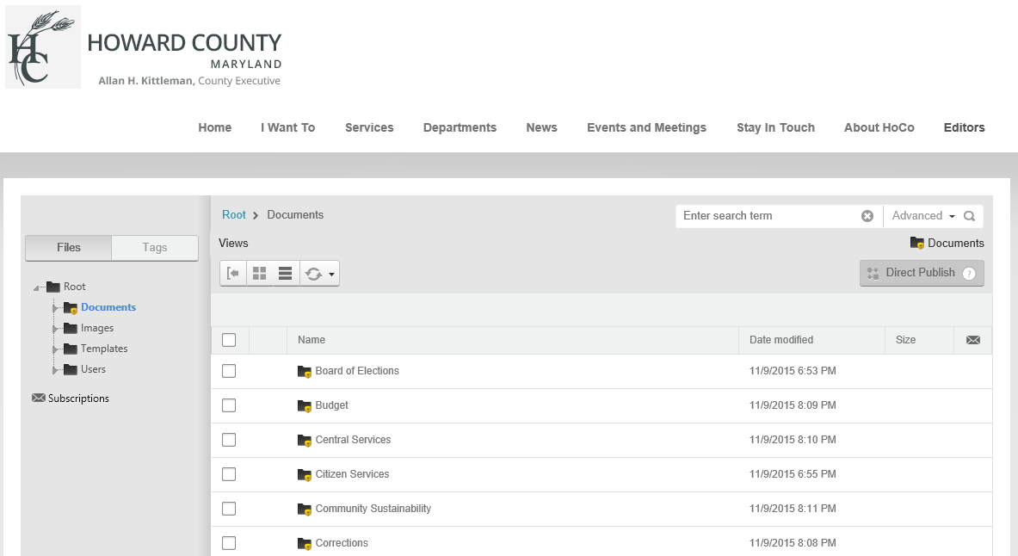
NOTE: The full list of departments will be a much longer list than what is displayed here.
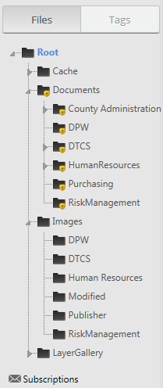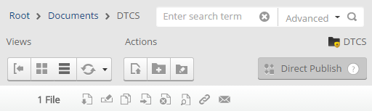

Views
Icon |  | Function | Description
 |  | Toggle | Collapse/expand the file navigation pane
 |  | Icons | View files in icon tiles
 |  | List | View files in a list
 |  | Refresh | - Refresh  - Sync this folder  - Sync this folder & subfolders

Actions
Icon | Function | Description
 | Upload Files | Accessible to Content Editors and Content Managers for their department's file section only.
 | Create New Folder | Accessible to Content Editors and Content Managers for their department's file section only.
 | Manage Folder Types | Accessible to Site Admins only.

Selected Files
Icon | Function | Description
 | Download | Download a copy of the file
 | Rename* | Change Filename
 | Copy | Copy File
 | Move | Move File to another location
 | Delete | Content Managers and Admins ONLY
 | View Properties | Available for all department's files
 | Get URL* | Provide URL to file
 | Subscribe | Get email update if file or folder is updated

Action Buttons

Upload files
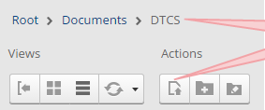
- Navigate to the Folder to which the files will be uploaded.
- Click on the Upload Files action button.
- The Upload Files dialog box opens.
There are a few options
- Upload Files | Drop and drag files using your file explorer or click on the box to browse for a file.
- From URL | Enter the URL where the desired file resides. Enter the URL and click the Upload button.
- Decompress Zip Files | Check the box to decompress zip files as the file is uploaded. Use caution and only use this feature on files you trust.
The Upload Files dialog box indicates where the files will be uploaded to. If this is not correct, click close and navigate to the correct location before clicking the Upload Files button again.
Try to keep file names under 25 characters if possible.
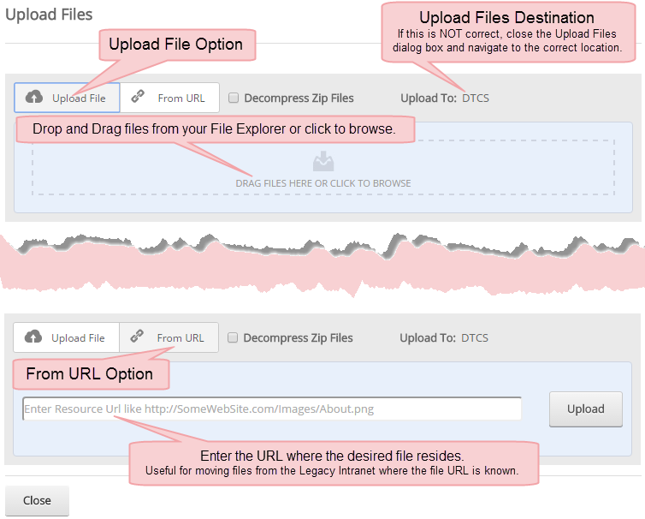

Replace or Keep Existing Files
If you upload a file with the exact same name as on that already exists, you will be prompted to Replace or Keep the existing file.
Replace | The replace option updates all existing links to the new file. The Link reference is preserved so that links in external documents will now point to the new document.
Keep | The Keep option will add the word (Copy) to the new file's filename. Existing links will NOT be updated to the new file and any external links will open the document referred to in the original Link URL.
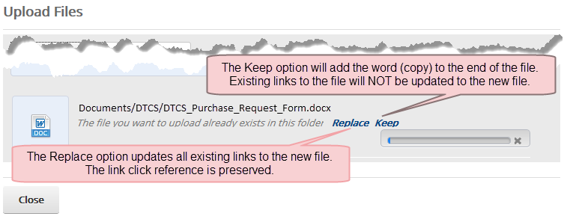

Create a Folder
You may create subfolders in your department's Folder ONLY. This option will not be available for you to add folders to other department's structure.
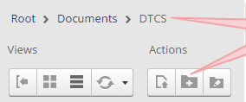
- Navigate to the Parent Folder in which the new folder will be created.
- Click on the Add Folder action button.
- The Create New Folder dialog box opens.
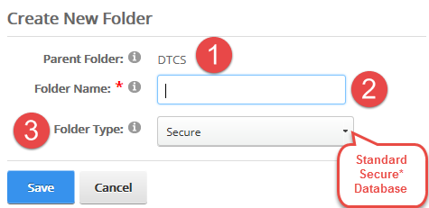
- Parent Folder: Your department's folder.
- In the Folder Name text box, enter a name for the new folder.
- From the Folder Type dropdown, select Secure.
- Click Save to create the folder or Cancel to cancel the folder creation.

Manage Folder Types
This action is limited to Site Admins only.
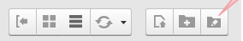
- Nothing happens when the Manage Folder Types action button is clicked.

Selected File Action Buttons
Action |  | Description
Download  More than one file or folder may be selected. The selected file(s will download. |  | Download behavior is based on the browser you are using.
Rename  NOT available when more than one file is selected. Allows file to be renamed. To avoid problems, do NOT change the filename extension! |  | 
Copy  Copy the selected files to another location in the File Management interface. More than one file or folder may be selected. Navigate to the "copy to" location and click the Copy Files button to confirm copy or Cancel. |  | 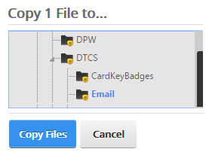
Move  Move the selected files to another location in the File Management. More than one file or folder may be selected. Navigate to the "move to" location and click the Move button to confirm move or Cancel. |  | 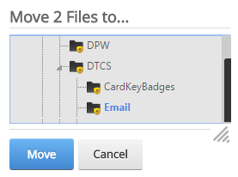
Delete  Accessible to Content Managers and Site Admins only. Content Editors cannot delete files. More than one file or folder may be selected. Click the Delete button to confirm deletion or Cancel. |  | 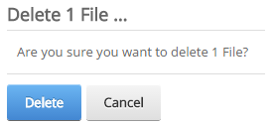
View Properties  Not available when more than one file or folder selected.  You can add a title, change the file name, add tags, set attributes, and set a publish period.  To set a publish period; first, check Enable then set a start and end date.  Click Save to save changes or cancel to close the properties window. | 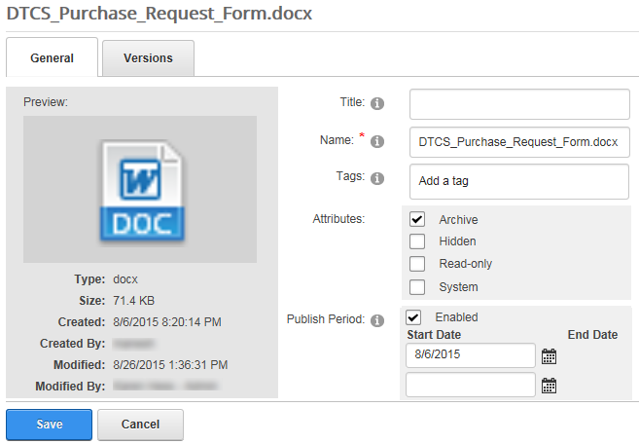
Get URL*  Not available when more than one file or folder selected. Place cursor in the URL box, right-click copy to copy URL.  Use this to create links from external sources ONLY. Use the hyperlink manager to add a link to a page. |  | 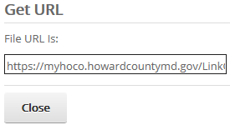
Subscribe  Subscribe to be notified of any changes to a file or folder. Subscribed files are designated by an envelope. |  | 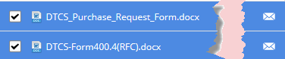

General Guidelines & Styling

Overview & Guidelines
This section discusses what styling options are available to you as you enter content into the new site via the rich text editor, the use of which is described above. The new site design includes a pre-selected group of fonts and font-colors that you can use to style your content. What follows is a description of these options, a guide for when it is best to use certain page-section layouts, and an example of a page that uses the discussed styling options.

User Guidelines from PIO
This section lists specific style guidance from the Public Information Office. All guidelines will be reinforced by PIO via the full review process.
- The Departmental Home Page should be regularly updated with fresh/current content.
  - Do not place Mission Statements or Director Photos on the Departmental Home Page.
  - Smaller departments with less content may potentially place Mission Statements and/or Director Photos at the bottom of the home page underneath current content.
- All images used in the web site must have an aspect ratio of 16:9.
- Do not use subdomains (e.g. “subdomain.howardcountymd.gov”) instead convert these links to aliases.
- Use “Residents” to refer to individuals who live within Howard County.
- Either “The County” or “Howard County” may be used.
  - Be consistent within a single page and only use one or the other therein.

Fonts and Colors
The site is designed to use a sans-serif font by default when presenting content to the user. The rich text editor is built to automatically use this font along with the approved color palette (see below) for use with the site design. You should not deviate from this when entering your content into the site; we don’t want editors changing the sizes and colors of text. Exceptions will only be made on a case by case basis.

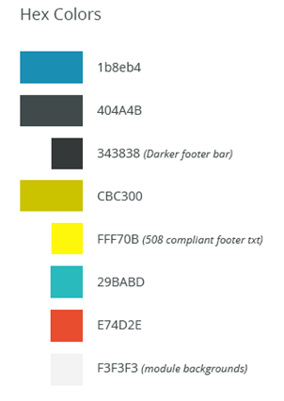

Page Layout
The page template provides several different zones for you to use:
- 100%
- 50/50%
- 75/25%
These are provided in the following format. There are a total of 10 rows and a total of 14 zones.
- 100
- 100
- 50/50
- 75/25
- 100
- 100
- 50/50
- 75/25
- 100
- 100
An example is shown below.
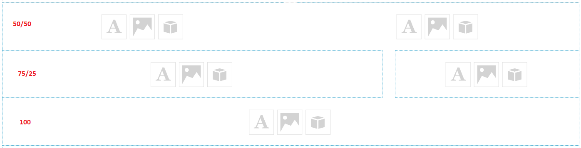
For most of your pages, you will use the 100% section on the page to enter your content. The 100% section is flexible enough to allow for the entry of both rich text and images in-line with each other. However, there are times when you may want to use the other sections.
The 50/50 sections of the page are an easy way to introduce a 2-column layout to your page. Potential use cases include a long list of content, like a list of links, or a list of contacts. Using 50/50 for long lists will reduce the amount of scrolling a site visitor needs to do to find the content they need. On smaller screens the right-hand section will move to be underneath the left-hand section, providing users with a continuous list of content.
The 75/25 sections of the page are best used when you have a main block of content to present on the page but also wish to provide an image that stands out clearly from the content, or you have additional content that is related to but not part of the body content. Using 75/25 is a good way to make this related content readily visible to the site visitor but not buried at the bottom of the page after the main block of content. Images with long captions, Call-out text (e.g. a short quote from a longer passage), or additional information like contact details or further instructions to the site visitor are potential used for the 25 part of 75/25.

Basic HTML Guide
You may want to format your page text manually, or manually insert tabular information. To do this you will use HTML, which stands for “HyperText Markup Language.” HTML is made using tags, and there is a list of basic tags that you can use to manually format your page content below. To use an HTML tag, you type the tag, then type the content that the tag applies to, then close the tag. You close the tag by adding a slash (“/”) to the tag after the opening bracket. All the tags below show both the tag and its closing partner. For more information about HTML, please visit http://www.w3schools.com/html.

Formatting Tags
These are the basic HTML formatting tags that you can use on your content.
- Paragraph <p></p> -- Use these to format a paragraph of text.
- Line break <br/> -- This tag has no closing tag, use it to start a new line of text outside of a paragraph, or to add a blank line to your content.
- Strong <strong></strong> -- Use this to make your text bold in a section 508 compliant manner.
- Emphasis <em></em> -- Use this to make your text italics in a section 508 compliant manner.
- Underline <u></u> -- Use this to add an underline to your content.

Lists
Use these tags to add a bulleted list of content, just like this section of the manual.
- Unordered List <ul></ul> -- This tells the browser to look for <li> tags. When using this tag you type the opening tag (“<ul>”), then enter all your list items (“<li></li>”), and then use the closing tag (“</ul>”) (see example below).
- List Item <li></li> -- Use this for the items in your list.
Sample Unordered List
<ul>
<li>Item 1</li>
<li>Item 2</li>
</ul>

HTML Tables
Use these tags to create a table of content.
- Table <table></table> -- Similar to the <ul> tag, use this to indicate the beginning and the end of the table (see example below).
- Table row <tr></tr> -- Use this to start and end a table row. <th> and <td> tags go inside the <tr></tr> tag.
- Table header <th></th> -- Use this to indicate the header row of the table in a section 508 compliant manner.
- Table data <td></td> -- Use this to indicate the cells of content in your table. There should be the same number of these on every line, including the <th> line.
Sample Table
<table>
<tr>
<th>Header 1</th>
<th>Header 2</th>
</tr>
<tr>
<td>Content 1</td>
<td>Content 2</td>
</tr>
</table>

Accessibility Guidelines & Considerations (Section 508)

Overview
Section 508 is an amendment to the Federal Rehabilitation Act that is designed to eliminate barriers in access to Information Technology. For the purposes of this document, we will provide some Best Practices for achieving Section 508 compliance.

Best Practices

Page Layout
This section refers to the proper formatting of content on the pages you will create.
- Proper header formatting should be used to mark off sections of your content on the page.
  - While the CMS will automatically handle the page title itself, you want to be sure to use the largest header option available in the CMS for section titles. The next size down of header in the CMS should be used for any sub-sections of content on a page.
- Anchor tags should provide clear visual cues that the user has moved to the chosen section.
  - This includes the browser windows scrolling to the chosen content section, which is standard browser behavior.
- When using an <iframe> tag, make sure that the title attribute is used.
- The user should be able to increase the size of the text on the page.
  - Modern browsers incorporate this feature
- Make sure to employ a high color contrast for the content on the screen
  - The site’s design will do this automatically for basic text, but for any custom tables that you add use light-colored fonts on dark backgrounds and dark-colored fonts on light backgrounds.

Navigation – External Links
This section refers to the proper formatting of links to other content that will be included on your pages. This always refers to links within the page content and not the site’s navigation, which will be manage by DNN. The CMS will also style the link so that linked text will stand out from plain text on your page.
- Make sure the link’s text describes the destination
- Use the title attribute in a text link to provide additional information about the link.
- When using images as links make sure to use the alt attribute for the image to provide additional information about the link.

Images
This section refers to the proper way to apply additional information to any images you add to your page.
- Make sure to always populate the alt tag for an image to provide information about the image for screen readers.
- Complex images should have a more detailed description to accurately describe the content of the image.
  - This is especially true for any charts or diagrams that are added to a page.
  - These additional details can be placed in line below the image, or via a view/hide button directly below the image.
- If you add text to an image file in photo-editing software, make sure that text is:
  - Present in the alt tag for the image
  - Highly-contrasted against the part of the image that is the background of the text.
    - Use light-colored fonts on dark backgrounds and dark-colored fonts on light backgrounds.

Tables
This section refers to the proper way to add tables of information to your page.
- Use the summary attribute to add a brief synopsis of the table’s purpose.
- Table headers should be properly contrasted against content cells
  - If manually creating a table using HTML, use the <th> tag with the ARIA role attribute for table headers.
- If manually creating a table using HTML associate data cells with the corresponding header cells.
  - For simple tables use the scope attribute to tie header cells to the corresponding data cells.
  - For complex tables use the header and id attributes to tie header cells to the corresponding data cells.
- If a table has been sorted use the <caption> tag and the tag’s ARIA and title attributes to provide information about how the table has been sorted.

For More Information
For more information about Accessibility and Section 508 compliance, please visit these links:
- Section508.gov
http://www.section508.gov/content/guidance
http://www.section508.gov/content/learn/best-practice-library
- Creating Accessible Websites
https://cio.gov/creating-accessible-websites/
- SSA Accessibility Best Practices Library
https://www.ssa.gov/accessibility/bpl/default.htm

Managing News

Overview
This section of the manual will cover the News Module, including adding and modifying News articles.
The News module allows you to post News articles that will appear on the website. News articles will represent county-wide and department-specific news. PIO users will have access to create and edit news articles, although all news articles will be approved by PIO before posting to the public site. All news articles posted to the site will be listed under the main ‘News’ section accessible from the top navigation of the site, and may be filtered by site users per pre-determined selected categories. News articles specific to a Department will also be available from the ‘Department News’ section in the Spotlight area of each Department’s web pages. Categorizing a news article as related to a Department will cause the news article to be listed in these department news sections (as described further below). Additionally, PIO has administrative access to promote your news articles to the front page of the HowardCountyMD.gov website.
Descriptions for viewing news articles and to access the News Articles module to add and edit news articles are included the sections below.

Viewing News Articles
News Articles can be accessed from anywhere on the howardcountymd.gov website by clicking the News button in the top-nav. One entire News Article has been outlined in the image below.
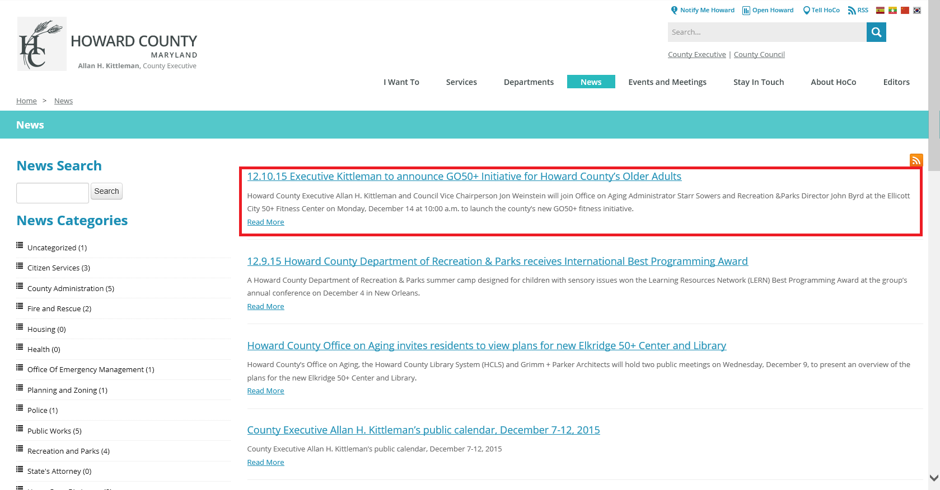
Clicking on the Title or the Read More links for the News Article will cause the entire News Article to display.
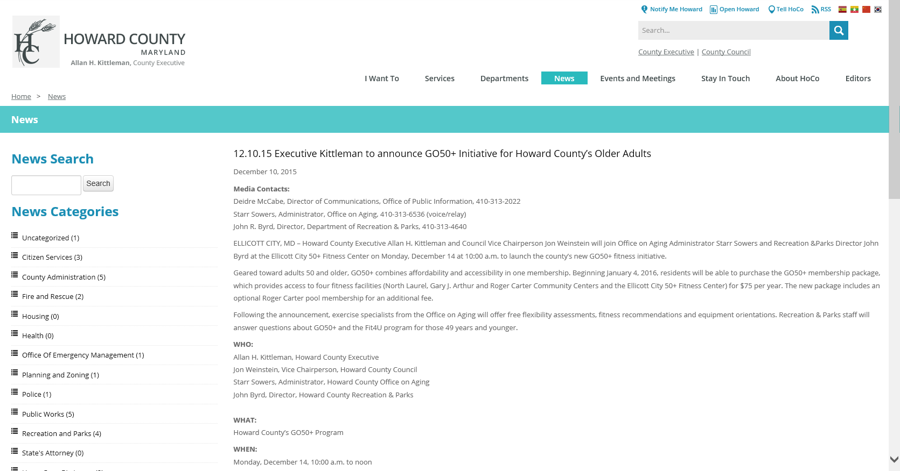

Accessing the News Module
Log in to the CMS using an account with Content Editor or Content Manager access. The Editors option will appear in the top-nav. Hover over Editors and click on For News Editors (you will need to be given specific access to the News Module by IT).
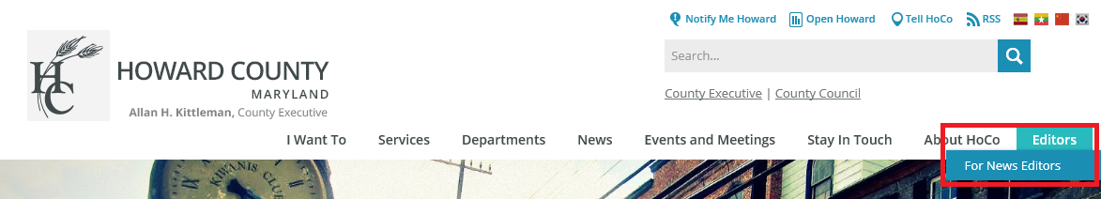
The News screen appears.
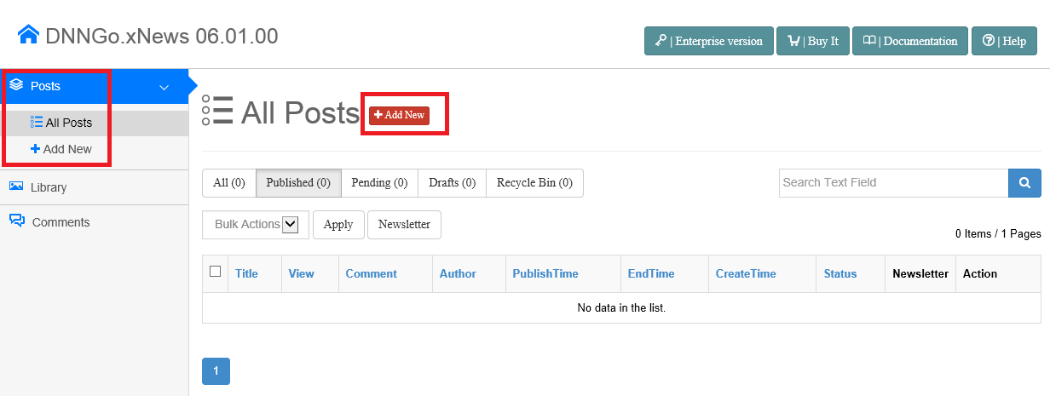
Specific areas that you should pay attention to are located along the left navigation area under the Posts navigation item.

- All Posts – This shows a list of All Posts that you have access too. News Articles will only be listed here if you created them. Editing of news articles is limited to the individual user that created the news article, not to any user in a Department to which the article is related by the Category selection (description of Category selection and Department association described further below in Adding a News Article). For instances where a News Article was created by another person, but access to that article is required (for example, if the original creator is out on vacation, out sick, employment terminated, etc.), you will need to contact PIO to gain access to that article or to have the News Article updated.

- Add New – This allows you to add a new News Article. There is also a red “+ Add New” button in the middle of the screen that offers the same functionality.

Adding a News Article
Click the Add New button. The Add New Post screen appears.
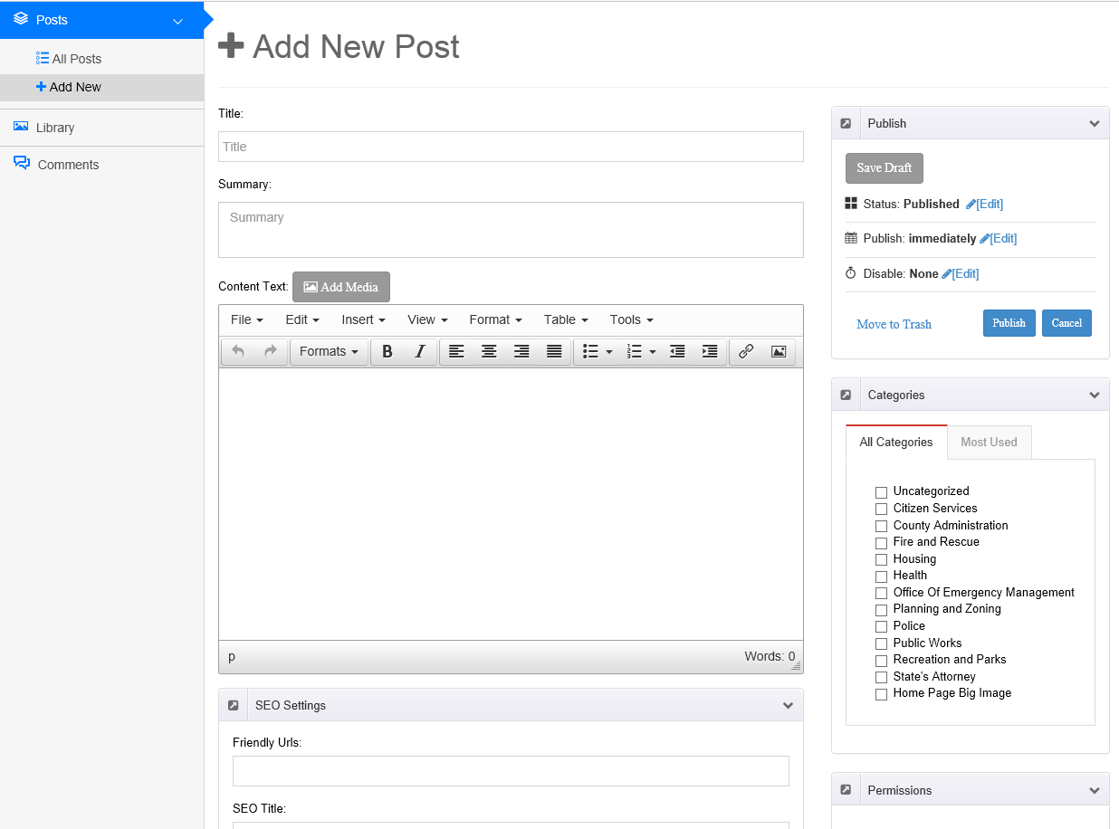
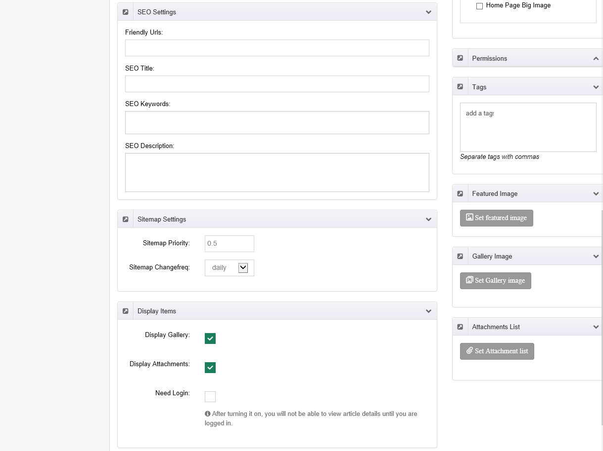
You will be required to fill out the following fields:
  - Title – This is the headline for the article.
  - Summary – This is the blurb that shows up on the main news page and on departmental page.
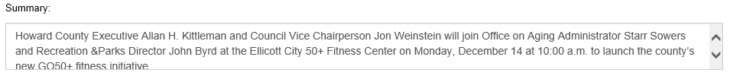
  - Content Text – This is the full text of the article. On the main news page, the citizen must click on the Read More link to view this text. On the departmental page the citizen must click on the title to view this text. Several text markup functions are available to you, including Formats, Bold, Italics, Text Alignment, Lists, Links, and Images.
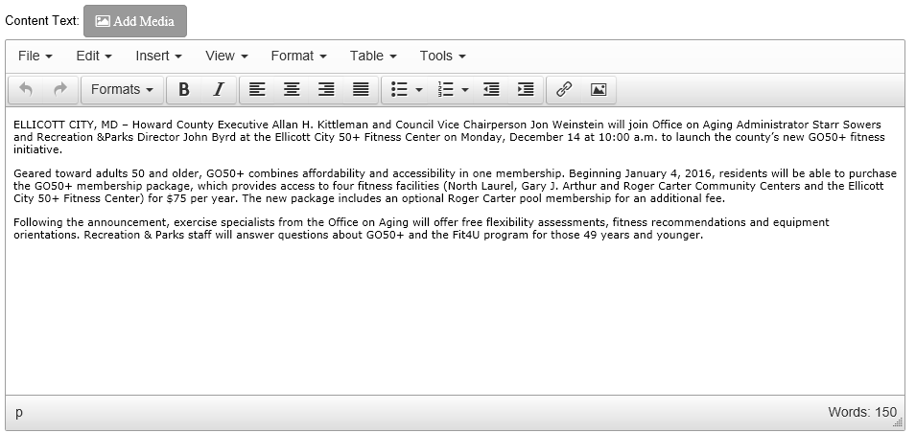
  - Publish Options
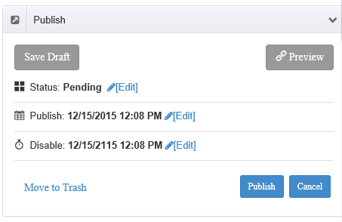
    - Status – Published is the default option. However, there are other options to prevent articles from showing on the site. Users can select published, but the Article will still be saved as Pending until PIO approves it.
    - Publish (Date) – This is where you enter the publish date of the article…the date of the press release, for example.
    - Disable (Date) – This is where you determine when articles will be taken off of the site. By default, it’s set to 100 years in the future but for some articles you might want to have them automatically hide after a set period of time.
    - Clicking the PUBLISH button saves and sets it as Pending and SAVE DRAFT saves your changes without initiating the workflow.
  - Categories
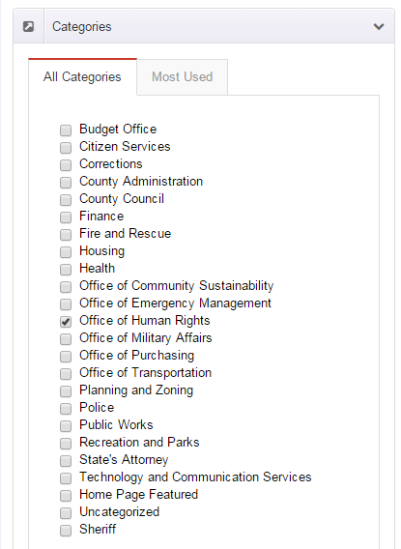
    - Picking one or more departments will show the article on the respective department’s news page. Departments should use caution with this to prevent scenarios such as Department A labels an article Department B and it ends up showing on Department B’s page when it shouldn’t. If an article involves more than one department then the author should coordinate with the PIOs of those departments before selecting more department categories.
    - Picking the HOME PAGE FEATURED category will show it on the “hero” image slider at the top of home page. Non-admin users should not use this functionality.
  - Permissions – Do not modify anything in this section.
  - Tags – Tags are optional and affect the “related articles” feature of the module. As you add tags, they will turn into green rectangles. To remove a tag, simply click the ‘x’ that is at the right side of the tag.
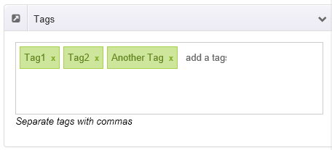
Article Author – You do not need to change this. By default, the author is set to the person who created the article. However, it can be overridden. As of this time this document was written, the CMS does not show the article author on the news pages so the citizens would never see this.
  - Featured Image - This is the thumbnail image for articles as well as the hero image if PIO chooses to put that article on the home page.
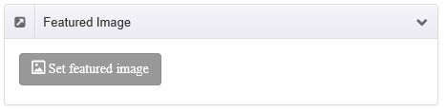
  - Gallery Images – You can associate additional images with the News Article by using this functionality.
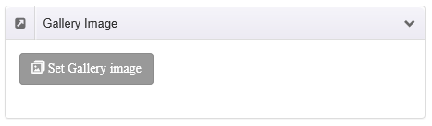
  - Attachments List - You can attach documents to a News Article by using this functionality.
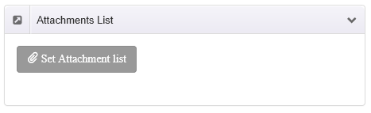

When using any of the Image/Attachment functionality described above, you’ll be presented with a pop-up screen where you can choose from a list of pictures, as shown below.
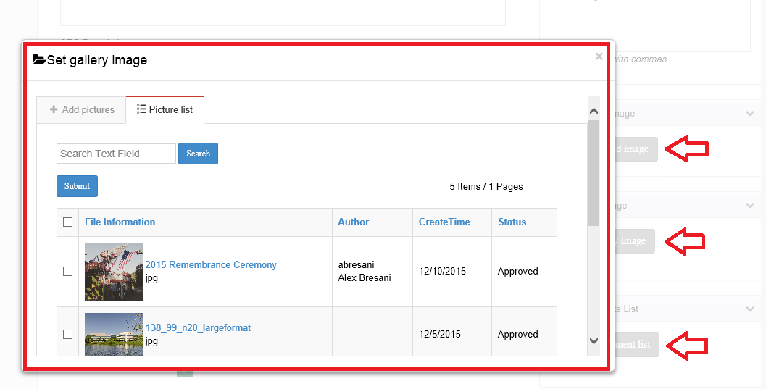
To add new pictures, click the Add pictures tab and then drag/drop your pictures onto the Drop files to upload area.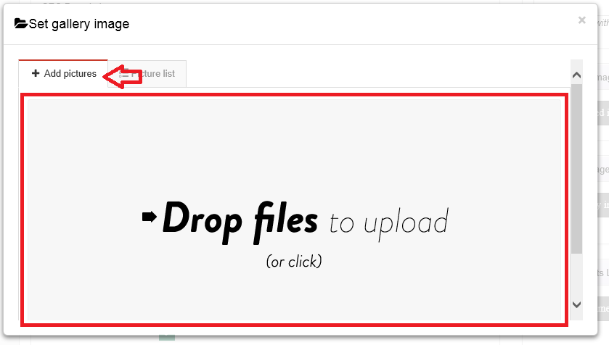

Editing an Existing News Article
To edit an existing News Article that you have access to, click on All Posts in the Posts navigation area, then click the blue ‘edit’ button in the Action column.
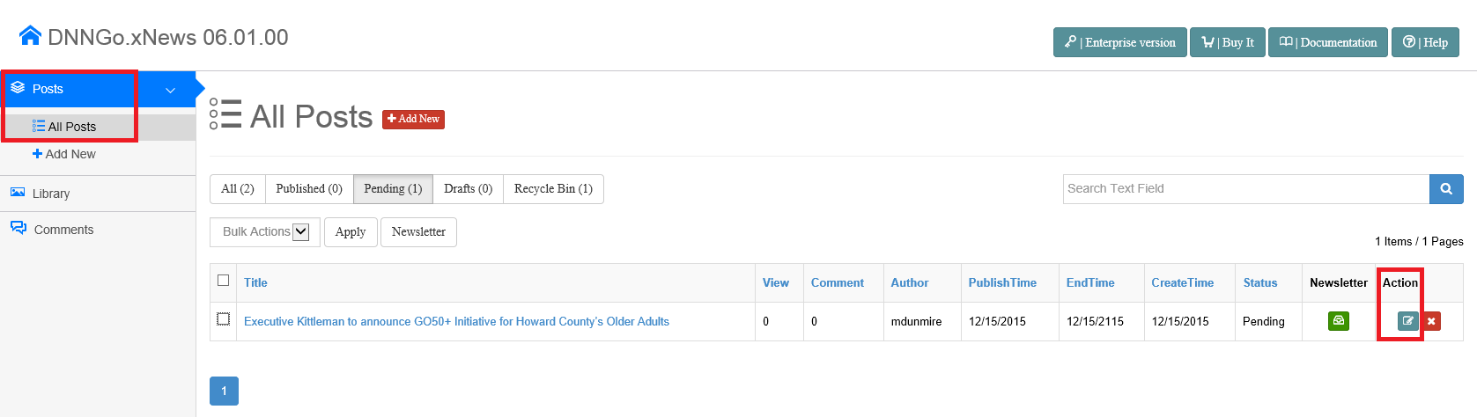
This will open the Add New Post screen that was covered above. Please note that you are actually editing the existing News Article even though the screen says Add New Post.

Managing Calendar

Overview
This section of the manual will cover adding and editing calendar items. The calendar module allows you to post meeting and event information that will appear on the website. The main calendar section is accessed by clicking “Events and Meetings” from the top navigation. This main calendar displays all the events that have been entered into the calendar module. Your department’s calendar items will appear by themselves on the calendar page listed in the Spotlight nav in your department’s section of the website.

Adding a Calendar Item

Accessing the Calendar Admin
To add a calendar item, log in to the website and click “Events and Meetings” in the top nav.
When the Events and Meetings page loads, place the page in Edit Mode.
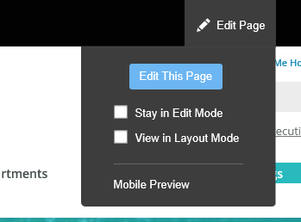
When the page is in edit mode, click the pencil icon at the top of the calendar module and click “Event Planner Admin.”
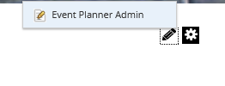

Scroll down the page to the section titled “Add/Edit Events” and click the “Event Admin Menu” button.
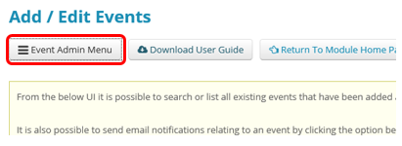
Figure 1 Note that at if you do not find the answer to your question in this manual, you can download the User Guide for the calendar module from the button shown in this image.

When clicked, the Event Admin Menu presents options. To add an event, click “Add New Event.” Click “View All Events” to view a list of all the events you have entered. The rest of the Amin Menu options are not to be used at this time.
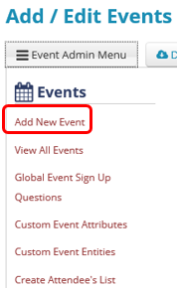

Adding the Event

Details tab
When you click “Add New Event,” the add event entry form will open on the “Details” tab. Note that you may have to scroll down the page to bring the items into view. Complete the form for the items indicated below, ignoring the other fields.
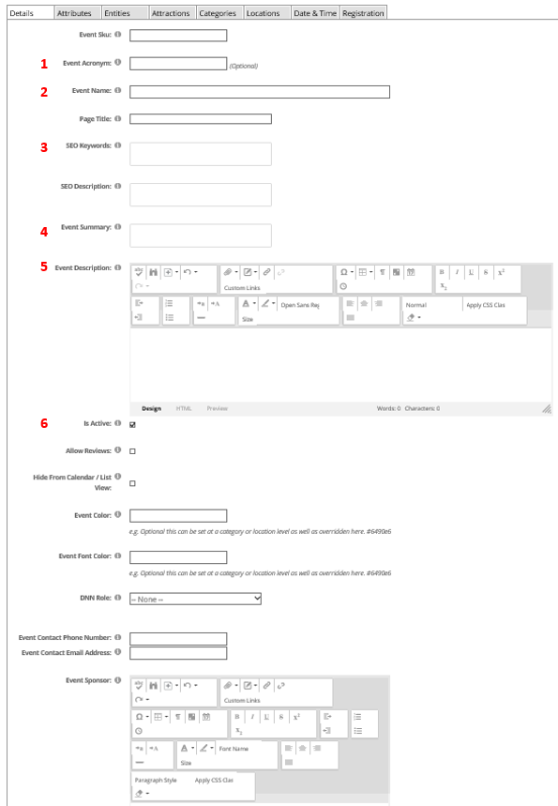
# | Name | Description
1 | Event Acronym (optional) | If you have a long Event Name (2), then enter an acronym for your event. This will show in the Calendar view instead of the Event Name, saving space.
2 | Event Name (required) | This is the title of your event, and will appear everywhere the event shows, including as the page title in the browser tab.
3 | SEO Keyword (optional)  SEO Description (optional) | SEO Keywords and Description are optional sections that you can use to help your event appear in search engine results.
4 | Event Summary (required) | This is a brief summary of your event that will appear by default.
5 | Event Description (required) | This is the long description of your event and should include all relevant details that potential event-goers will need to know.
6 | Is Active (optional) | You can prevent your event from appearing on the site by clicking this check box.

Categories Tab
When you have completed the above fields, click on the “Categories” tab at the top of the module and at minimum select the category for your department.
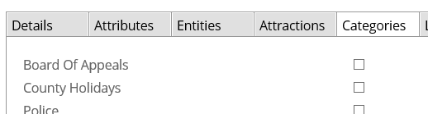

Date & Time Tab
When you have selected the applicable category(ies), click the “Date & Time” tab and complete the fields as necessary for your event. Note the presence of the “Is Recurring Event” checkbox.
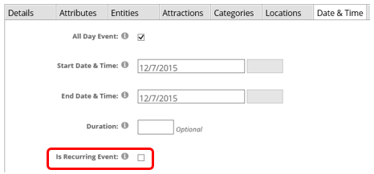

Recurring Events
When you click the “Is Recurring Event” checkbox, you will see multiple options appear on the form that allow you to set a recurrence for this event so that if it recurs, you only have to enter the event once, and any changes you make to the event will automatically apply to all the recurrences.
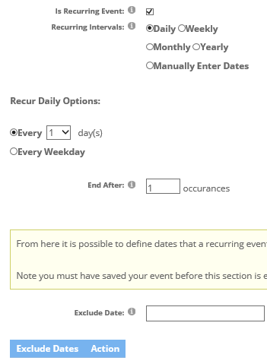

Saving Your New Event
When you have completed all three tabs, click the “Save” button at the bottom of the module to add your event to the calendar. You can always click “Cancel” to stop adding the event.
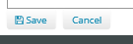

Editing an Existing Calendar Item
Log in and access the Calendar admin module as described above, and scroll to the bottom of the module to see the list of events that you have previously entered.
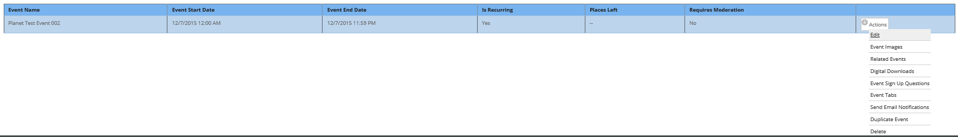

Click on the Actions menu to the right for the item you want to edit and select one of the three below-highlighted options.
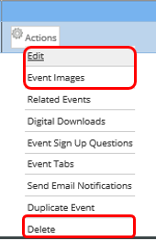
If you chose “Edit,” the event will open and you will edit it using the same forms and tabs as described above in Adding a Calendar Item. Choosing “Delete” will remove the item from the calendar.

Event Images
After an item is created you can add an event image in the body of the event (HTML editor). This is highly recommended. If the event does not have an image that can be used (e.g. fireworks for a July 4th event), then it is recommended that either the Department / Bureau’s logo be used, and failing that, use a square version of the Howard County logo.

Appendix
Content in this section of the document contains tips & tricks, page layout examples, and other helpful information.

Examples:

Event Page (Single page using Text Editor and Accordion Module)
The example below describes how you may want to develop a web page for an event. For most events, they occur on a yearly basis, and you want to be able to have a page for information about the upcoming event, and also be able to maintain information about previous events. Some issues that you may run into in this scenario:
- Citizen navigates to the website on a day in 2015 and does a search for July 4 event. Search results returns links to all of the previous year event pages. Citizen clicks on the first link, which ends up being for the 2012 event. This scenario happens a lot and is frustrating for users.
- Content Editor/Manager is responsible for maintaining current event page and previous year pages. Every year, a new page must be added, content copy/pasted from current year into the new page, and current year page updated. With every year that passes, the list of pages that the Content Editor/Manager has to maintain, as well as the amount of pages the Citizen has to click through, grows and becomes cumbersome to maintain.
A suggest that has been made for streamlining this process in the new DNN CMS is to maintain a single event page. On that page, you would use a 100% width module with a Text Editor, followed by another 100% width module with an Accordion Tab. Below is an example of how this may look:
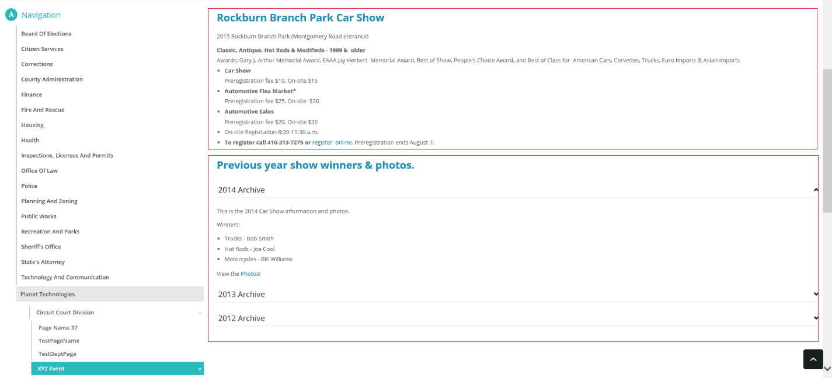
In this scenario, 2015 is the current year, and there is historical information listed for 2014, 2013, and 2012. When the 2015 event has completed, the Content Editor/Manager would:
- Add a new Tab to the Accordion Menu, titled 2015 Archive
- Copy/paste as much of the information into the new Accordion Tab as needed
- Update the Text Editor with the 2016 event information

Some benefits of using this method to maintain event pages:
- When a Citizen searches for the event, they’ll only ever find 1 result, so the link they click will always take them to this single page with the most current information, plus the ability to view historical/archived event information on the same page.
- Content Editor/Manager only has to maintain a single page per event, reducing time invested in maintaining the website.
To configure this type of page, click Edit Page, then on your page template, find a place where you have (2) 100% zones. In the first zone, add the Text Editor. In the second zone, add the Accordion Tabs module.
- Add the Text Editor
- Add a Module
- Choose the Accordion Tabs module
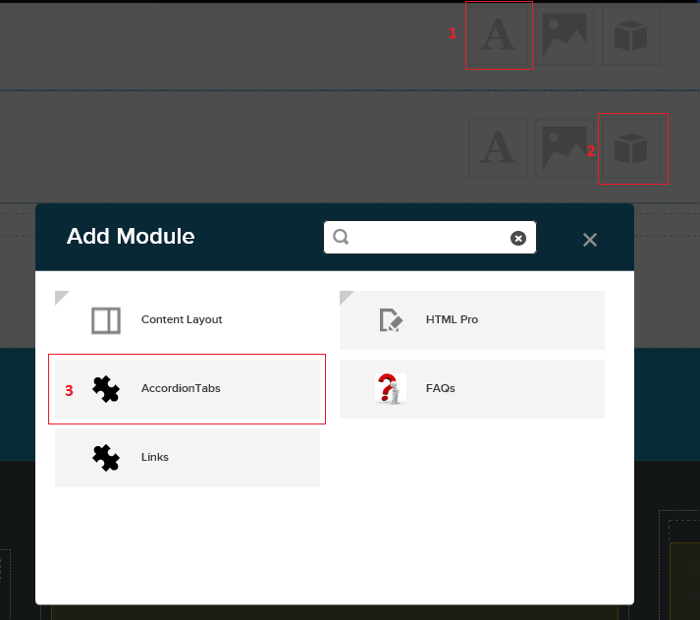
Continue to build out the page using the knowledge you’ve gained from previous sections of this document.

Anchor tabs vs. Accordion Menu
In some cases, you may have a lot of content that needs to be placed on a single page. If this content can be categorized, you have a few options available to make the page easier to managed and navigate. Two of those options are:
- Anchor Tags – Anchor tags are created within the Text Editor. Anchor tags are similar to hyperlinks, but they are generally on the same page instead of another page. To use Anchor Tags, you must create Anchors with the content through the Text Editor. After the Anchors are created, you must then create the links on the page that link to the Anchors. This method, when configured correctly, looks like a Table of Contents. Generally, the Table of Contents is located at the top of the page, and each line in the ToC links to an Anchor further down the page.
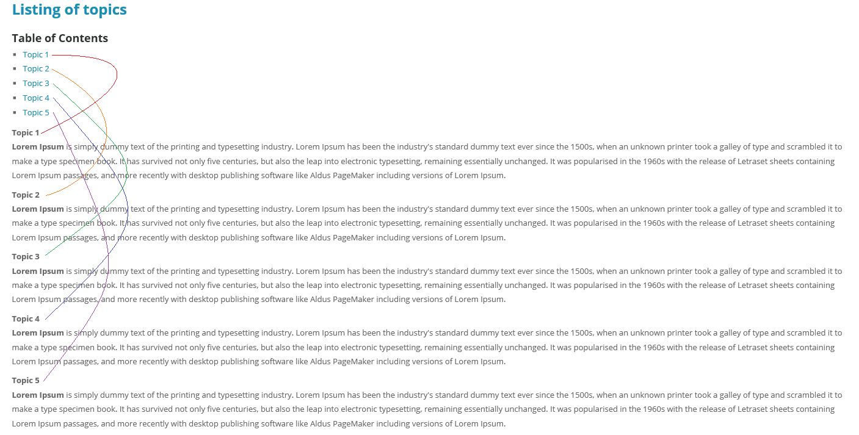
- Accordion Tags menu – This Module enables you to create 1 or more Tabs. Each Tab has a Title, followed by a collapsible content area. Using this method, you can categorize content by using the Tabs, while populating the content areas with the content. Citizens will have the ability to open/collapse each of the Tabs to show/hide content on the page.
