
  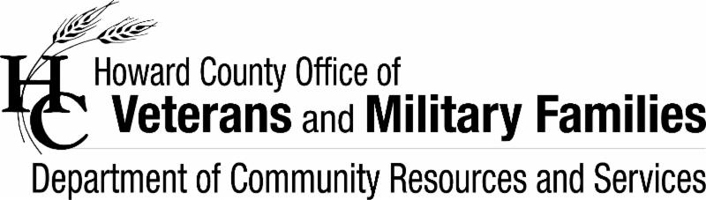
  Dear Veterans, Military Families and Supporters,
  You will find the latest copy of my e-bulletin below with a number of resources to benefit veterans and military families. They are not endorsed by my office, just a compilation of programs and services that come across my desk. Please feel free to share and vet according to your needs. If you have any events, programs, job opportunities, etc. that would benefit this group, please forward to me. If these bulletins have benefited you, a colleague or family member, please share your confidential story with me. You can find previous resource bulletins at www.howardcountymd.gov/veterans
  Resources for Veteran and Military Families
  4 December 2019
  E-Bulletin

